**April 2020** **Challenge**

Introduction

Welcome to the 30-Day LeetCoding Challenge!

With many of us around the world being encouraged to stay indoors and work from home, **this is the perfect opportunity for you to focus on studying up for future code interviews**. In order to help you stay focused, LeetCode is running the **30-Day LeetCoding Challenge** for the month of **April**. A problem will appear here at **midnight PDT** each day, and you'll have **24 hours** to solve it and **submit it here on the Explore Card**.

Solving a problem **within 24 hours of it appearing here** will **reward you with LeetCoins**. Completing all 30 on the day they appear will reward you with **even more LeetCoins**, and an entry into a **prize draw** where **3 lucky winners** will win cool prizes! More details on the prizes can be found in the announcement.

**If you've previously solved the problem before, you *must resubmit* it here in this Explore Card for it to be counted.**

**IMPORTANT: All submissions to this 30-Day LeetCoding Challenge must be made in this Explore Card to be counted.**

If you miss a problem, it'll still be here for you, however, you won't get any LeetCoins for it, and you'll no longer be eligible for the prize draw.

Check out [the announcement](https://leetcode.com/discuss/general-discussion/551411/30-Day-LeetCoding-Challenge) for more information. Also, don't forget to [add the event to your calendar!](https://calendar.google.com/calendar/r/eventedit?ctz=America/Los_Angeles&dates=20200401T000000/20200401T235959&text=30+Day+LeetCoding+Challenge&location&details=https://leetcode.com/explore/challenge/card/30-day-leetcoding-challenge/&recur=RRULE:FREQ%3DDAILY;UNTIL%3D20200430T235959Z&sf=true)

Good luck, and happy coding! We wish you all the best with your interview preparation.

[](https://leetcode.com/subscribe/?ref=ex_dc)

Week 1: April 1st–April 7th

 Single Number

 Happy Number

 Maximum Subarray

 Move Zeroes

 Best Time to Buy and Sell Stock II

 Group Anagrams

**Counting Elements**

Week 2: April 8th–April 14th

**Middle of the Linked List**

 Backspace String Compare - G

 Min Stack

 Diameter of Binary Tree

**Last Stone Weight**

**Contiguous Array**

 Perform String Shifts

Week 3: April 15th–April 21st

 Product of Array Except Self

 Valid Parenthesis String

 Number of Islands

**Minimum Path Sum**

 Search in Rotated Sorted Array

**Construct Binary Search Tree from Preorder Traversal**

**Leftmost Column with at Least a One**

Week 4: April 22nd–April 28th

 Subarray Sum Equals K

**Bitwise AND of Numbers Range**

 LRU Cache

 Jump Game

**Longest Common Subsequence**

 Maximal Square

**First Unique Number**

Week 5: April 29th–April 30th

 Binary Tree Maximum Path Sum

**Counting Elements**

Given an integer array arr, count how many elements x there are, such that x + 1 is also in arr.

If there're duplicates in arr, count them seperately.

**Example 1:**

**Input:** arr = [1,2,3]

**Output:** 2

**Explanation:** 1 and 2 are counted cause 2 and 3 are in arr.

**Example 2:**

**Input:** arr = [1,1,3,3,5,5,7,7]

**Output:** 0

**Explanation:** No numbers are counted, cause there's no 2, 4, 6, or 8 in arr.

**Example 3:**

**Input:** arr = [1,3,2,3,5,0]

**Output:** 3

**Explanation:** 0, 1 and 2 are counted cause 1, 2 and 3 are in arr.

**Example 4:**

**Input:** arr = [1,1,2,2]

**Output:** 2

**Explanation:** Two 1s are counted cause 2 is in arr.

**Example 5:**

**Input:** arr = [1,1,2]

**Output:** 2

**Explanation:** Both 1s are counted because 2 is in the array.

**Constraints:**

* 1 <= arr.length <= 1000
* 0 <= arr[i] <= 1000

   Hide Hint #1

Use hashset to store all elements.

   Hide Hint #2

Loop again to count all valid elements.

## Solution

#### **Approach 1: Search with Array**

**Intuition**

The simplest way of solving this problem is to loop through each integer, x, checking whether or not it should be counted. This requires checking whether or not x + 1 is in arr.

define function count_elements(arr):

count = 0

for each x in arr:

if integer_in_array(arr, x + 1):

count = count + 1

return count

To implement the integer_in_array function in the above algorithm, we can use **linear search**. To do a linear search, we need to loop through each integer of arr. If we find the integer that we're looking for, then return true. If we get to the end of arr, then we know the integer is not there, and so should return false.

define function integer_in_array(arr, target):

for each x in arr:

if target is equal to x:

return true

return false

Many programming languages have a built in function for checking whether or not an integer is in arr, e.g. Python.

**Algorithm**

|  |
| --- |
| class Solution {  public int countElements(int[] arr) {  int count = 0;  for (int x : arr) {  if (integerInArray(arr, x + 1)) {  count++;  }  }  return count;  }  public boolean integerInArray(int[] arr, int target) {  for (int x : arr) {  if (x == target) {  return true;  }  }  return false;  }  } |

**Complexity Analysis**

Let N*N* be the length of the input array, arr.

* Time complexity : O(N^2)*O*(*N*2).

We loop through each of the N*N* integers x, checking whether or not x + 1 is also in arr. Checking whether or not x + 1 is in arr is done using linear search, which requires checking through all N*N* integers in arr. Because we're doing N*N* operations N*N* times, we get a time complexity of O(N^2)*O*(*N*2).

* Space complexity : O(1)*O*(1).

We are only using a constant number of single-value variables (e.g. count), giving us a space complexity of O(1)*O*(1).

#### **Approach 2: Search with HashSet**

**Intuition**

If you're not familiar with the HashSet data structure, check out our [Hash Tables Explore Card](https://leetcode.com/explore/learn/card/hash-table/) to get up to speed.

The above algorithm will work fine for the maximum array length we're given here. However, we can do a lot better than O(N^2)*O*(*N*2), and an interviewer will no doubt expect you to come up with a better way.

The reason why the algorithm above was so inefficient is because we're performing N*N* linear searches, each with a cost of O(N)*O*(*N*). When we have an algorithm that is performing many linear searches to check for item existence, we should instead be looking to change the way the data is stored so that the time complexity of doing each search is less.

Recall that looking up items in a HashSet has a cost of O(1)*O*(1). Creating a HashSet from an array of N*N* items has a cost of O(N)*O*(*N*). We only need to create the HashSet once. After that, we can then replace all O(N)*O*(*N*) linear searches with O(1)*O*(1) HashSet lookups.

Before we go any further, here is an algorithm that is incorrect. Try to spot what the problem is; we'll discuss it just below.

define function count_elements(arr):

hash_set = a new HashSet

add all integers of arr to hash_set

count = 0

for each x in hash_set:

if hash_set contains x + 1:

count = count + 1

return count

Did you spot the bug? If there were duplicates in arr, then the count returned will be too low!

Recall that a HashSet removes duplicates. Consider a case like arr = [1, 1, 2]. The HashSet will be {1, 2}. Therefore, the above code will loop over each integer in the HashSet, which is only one copy of 1. Yet arr had two copies of 1.

To fix it, we need to loop over arr, but do the existence checks using the HashSet.

define function count_elements(arr):

hash_set = a new HashSet

add all integers of arr to hash_set

count = 0

for each x in arr:

if hash_set contains x + 1:

count = count + 1

return count

**Algorithm**

|  |
| --- |
| public int countElements(int[] arr) {  Set<Integer> hashSet = new HashSet<>();  for (int x : arr) {  hashSet.add(x);  }  int count = 0;  for (int x : arr) {  if (hashSet.contains(x + 1)) {  count++;  }  }  return count;  } |

**Complexity Analysis**

Let N*N* be the length of the input array, arr.

* Time complexity : O(N)*O*(*N*).

Creating a HashSet from N*N* integers takes O(N)*O*(*N*) time. We then need to loop over each of the N*N* integers like before, except this time we check for x + 1 by seeing if it is in the HashSet; an O(1)*O*(1) operation. This gives us a total time complexity of O(N) + N \cdot O(1) = O(N) + O(N) = O(N)*O*(*N*)+*N*⋅*O*(1)=*O*(*N*)+*O*(*N*)=*O*(*N*).

* Space complexity : O(N)*O*(*N*).

The HashSet needs to store each unique integer from arr. In the worst case, all the integers in arr will be unique, meaning that the HashSet has a space complexity of O(N)*O*(*N*).

It's interesting to note that O(N)*O*(*N*) is an upper bound on the space complexity. If U*U* is the number of unique integers in arr, then the space complexity could more accurately be represented as O(U)*O*(*U*).

#### **Approach 3: Search with Sorted Array**

**Intuition**

Another way of changing the data storage to allow for more efficient searching is to sort it. Sorting has a time complexity of O(N \, \log \, N)*O*(*N*log*N*), and searching for integers in a sorted array, using binary search, has a cost of O(\log \, N)*O*(log*N*). This will give us a total time complexity of O(N \, \log \, N)*O*(*N*log*N*).

define function countElements(arr):

sort arr

count = 0

for each x in arr:

binary search for x + 1 in arr

if x + 1 is in arr:

count = count + 1

return count

The main challenge of this approach would be needing to implement your own binary search.

However, we don't actually need to use binary search! If we iterate over the sorted arr, then we know that if x + 1 exists, it will be after all the copies of x.

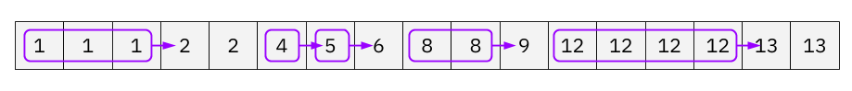

Each copy of x should be counted if at least one copy of x + 1 exists. Therefore, we can iterate down the sorted arr, keeping track of how many times the current x has appeared. When we get to a different integer, we can check if it's x + 1, and if it is, then the number of x we saw should be added to count.

define function countElements(arr):

sort arr

count = 0

run_length = 1

for each i in range 1 to arr.length - 1:

if arr[i - 1] is not equal to arr[i]:

if arr[i - 1] + 1 is equal to arr[i]:

count = count + run_length

run_length = 0

run_length = run_length + 1

return count

Here is an animation of this approach.



|  |
| --- |
| public int countElements(int[] arr) {  Arrays.sort(arr);  int count = 0;  int runLength = 1;  for (int i = 1; i < arr.length; i++) {  if (arr[i - 1] != arr[i]) {  if (arr[i - 1] + 1 == arr[i]) {  count += runLength;  }  runLength = 0;  }  runLength++;  }  return count;  } |

**Complexity Analysis**

* Time complexity : O(N \, \log \, N)*O*(*N*log*N*).

Sorting using a built-in sorting algorithm has a cost of O(N \, \log \, N)*O*(*N*log*N*). After that, we do a single pass through arr, which has a cost of O(N)*O*(*N*), giving us a total time complexity of O(N \, \log \, N) + O(N) = O(N \, \log \, N)*O*(*N*log*N*)+*O*(*N*)=*O*(*N*log*N*).

* Space complexity : varies from O(N)*O*(*N*) to O(1)*O*(1).

The space complexity of this approach is dependent on the space complexity of the sorting algorithm you're using. The space complexity of sorting algorithms built into programming languages is generally anywhere from O(N)*O*(*N*) to O(1)*O*(1).

Notice that you could implement your own O(N \, \log \, N)*O*(*N*log*N*) time complexity, O(1)*O*(1) space complexity, sorting algorithm if needed. In practice, O(N \, \log \, N)*O*(*N*log*N*) is not much worse than O(N)*O*(*N*), and so this approach provides an interesting contrast to Approach 2 (which had a space complexity of O(N)*O*(*N*)).

**Middle of the Linked List**

Given a non-empty, singly linked list with head node head, return a middle node of linked list.

If there are two middle nodes, return the second middle node.

**Example 1:**

**Input:** [1,2,3,4,5]

**Output:** Node 3 from this list (Serialization: [3,4,5])

The returned node has value 3. (The judge's serialization of this node is [3,4,5]).

Note that we returned a ListNode object ans, such that:

ans.val = 3, ans.next.val = 4, ans.next.next.val = 5, and ans.next.next.next = NULL.

**Example 2:**

**Input:** [1,2,3,4,5,6]

**Output:** Node 4 from this list (Serialization: [4,5,6])

Since the list has two middle nodes with values 3 and 4, we return the second one.

**Note:**

* The number of nodes in the given list will be between 1 and 100.

## Solution

#### **Approach 1: Output to Array**

**Intuition and Algorithm**

Put every node into an array A in order. Then the middle node is just A[A.length // 2], since we can retrieve each node by index.

We can initialize the array to be of length 100, as we're told in the problem description that the input contains between 1 and 100 nodes.

|  |
| --- |
| class Solution {  public ListNode middleNode(ListNode head) {  ListNode[] A = new ListNode[100];  int t = 0;  while (head != null) {  A[t++] = head;  head = head.next;  }  return A[t / 2];  }  } |

**Complexity Analysis**

* Time Complexity: O(N)*O*(*N*), where N*N* is the number of nodes in the given list.
* Space Complexity: O(N)*O*(*N*), the space used by A.

#### **Approach 2: Fast and Slow Pointer**

**Intuition and Algorithm**

When traversing the list with a pointer slow, make another pointer fast that traverses twice as fast. When fast reaches the end of the list, slow must be in the middle.

|  |
| --- |
| class Solution {  public ListNode middleNode(ListNode head) {  ListNode slow = head, fast = head;  while (fast != null && fast.next != null) {  slow = slow.next;  fast = fast.next.next;  }  return slow;  }  } |

**Complexity Analysis**

* Time Complexity: O(N)*O*(*N*), where N*N* is the number of nodes in the given list.
* Space Complexity: O(1)*O*(1), the space used by slow and fast.

**Last Stone Weight**

We have a collection of stones, each stone has a positive integer weight.

Each turn, we choose the two **heaviest** stones and smash them together.  Suppose the stones have weights x and y with x <= y.  The result of this smash is:

* If x == y, both stones are totally destroyed;
* If x != y, the stone of weight x is totally destroyed, and the stone of weight y has new weight y-x.

At the end, there is at most 1 stone left.  Return the weight of this stone (or 0 if there are no stones left.)

**Example 1:**

**Input:** [2,7,4,1,8,1]

**Output:** 1

**Explanation:**

We combine 7 and 8 to get 1 so the array converts to [2,4,1,1,1] then,

we combine 2 and 4 to get 2 so the array converts to [2,1,1,1] then,

we combine 2 and 1 to get 1 so the array converts to [1,1,1] then,

we combine 1 and 1 to get 0 so the array converts to [1] then that's the value of last stone.

**Note:**

1. 1 <= stones.length <= 30
2. 1 <= stones[i] <= 1000

   Hide Hint #1

Simulate the process. We can do it with a heap, or by sorting some list of stones every time we take a turn.

## Solution

#### **Approach 1: Array-Based Simulation**

**Intuition**

Conceptually, the simplest way we could solve this problem is to repeatedly search for the 2 largest stones in the array, delete them, and then if they are not the same size, add the new stone size back in. We can repeat this process until there is only one stone left.

**Algorithm**

Because the array is not sorted, there is no need to preserve the original order. Removals should be done by swapping with the last value, not by shuffling all values along.

|  |
| --- |
| class Solution {    private int removeLargest(List<Integer> stones) {  int indexOfLargest = stones.indexOf(Collections.max(stones));  int result = stones.get(indexOfLargest);  stones.set(indexOfLargest, stones.get(stones.size() - 1));  stones.remove(stones.size() - 1);  return result;  }  public int lastStoneWeight(int[] stones) {  List<Integer> stoneList = new ArrayList<>();  for (int weight : stones) {  stoneList.add(weight);  }  while (stoneList.size() > 1) {  int stone1 = removeLargest(stoneList);  int stone2 = removeLargest(stoneList);  if (stone1 != stone2) {  stoneList.add(stone1 - stone2);  }  }  return !stoneList.isEmpty() ? stoneList.remove(0) : 0;  }  } |

**Complexity Analysis**

Let N*N* be the **length of stones**. Here on LeetCode, we're only testing your code with cases where N ≤ 30*N*≤30. In an interview though, be very careful about such assumptions. It is very likely your interviewer expects you to come up with the best possible algorithm you could (thus handling the highest possible value of N*N* you can).

* Time complexity : O(N^2)*O*(*N*2).

The only non-O(1)*O*(1) method of StoneArray is findAndRemoveMax(). This method does a single pass over the array, to find the index of the maximum value. This pass has a cost of O(N)*O*(*N*). Once we find the maximum value, we delete it, although this only has a cost of O(1)*O*(1) because instead of shuffling along, we're simply swapping with the end.

Each time around the main loop, there is a net loss of either 1 or 2 stones. Starting with N*N* stones and needing to get to 11 stone, this is up to N - 1*N*−1 iterations. On each of these iterations, it finds the maximum twice. In total, we get O(N^2)*O*(*N*2).

Note that even if we'd shuffled instead of swapped with the end, the findAndRemoveMax() method still would have been O(N)*O*(*N*), as the pass and then deletion are done one-after-the-other. However, it's often best to avoid needlessly large constants.

* Space complexity : O(N)*O*(*N*) or O(1)*O*(1).

For the Python: We are not allocating any new space for data structures, and instead are modifying the input list. Note that this modifies the input. This has its pros and cons; it saves space, but it means that other functions can't use the same array.

For the Java: We need to convert the input to an ArrayList, and therefore the ints to Integers. It is possible to write a O(1)*O*(1) space solution for Java, however it is long-winded and a lot of work for what is a poor overall approach anyway.

#### **Approach 2: Sorted Array-Based Simulation**

**Intuition**

Note: This approach is no better than Approach 1. We're only including so that we can look at why it doesn't work as well as one might initially assume. See Approach 3 for the optimal approach.

To simplify the search-for-maximum process, we could instead maintain a sorted array. We'd need to sort the array at the start, and then ensure that each time we need to add a stone back, that we're maintaining the sorted order.

Unfortunately, inserting a stone into a sorted array is an O(N)*O*(*N*) operation. While we can use binary search to determine where we should put it, inserting it still ultimately requires shifting all of the stones after it down by one place. This makes the approach no better than the previous one from a complexity point-of-view (in fact, it's actually worse because the space complexity is now unlikely to be O(1)*O*(1)).

**Algorithm**

|  |
| --- |
| class Solution {  public int lastStoneWeight(int[] stones) {  List<Integer> stoneList = new ArrayList<>();  for (int stone : stones) {  stoneList.add(stone);  }  Collections.sort(stoneList);  while (stoneList.size() > 1) {  int stone1 = stoneList.remove(stoneList.size() - 1);  int stone2 = stoneList.remove(stoneList.size() - 1);  if (stone1 != stone2) {  int newStone = stone1 - stone2;  int index = Collections.binarySearch(stoneList, newStone);  if (index == -1) {  stoneList.add(newStone);  } else if (index < 0) {  stoneList.add(-index - 1, newStone);  } else {  stoneList.add(index, newStone);  }  }  }  return !stoneList.isEmpty() ? stoneList.remove(0) : 0;  }  } |

**Complexity Analysis**

Let N*N* be the **length of stones**.

* Time complexity : O(N^2)*O*(*N*2).

The first part of the algorithm is sorting the list. This has a cost of O(N \, \log \, N)*O*(*N*log*N*).

Like before, we're repeating the main loop up to N - 1*N*−1 times. And again, we're doing an O(N)*O*(*N*) operation each time; adding the new stone back into the array, maintaining sorted order by shuffling existing stones along to make space for it. Identifying the two largest stones was O(1)*O*(1) in this approach, but unfortunately this was subsumed by the inefficient adds. This gives us a total of O(N^2)*O*(*N*2).

Because O(N^2)*O*(*N*2) is strictly larger than O(N \, \log \, N)*O*(*N*log*N*), we're left with a final time complexity of O(N^2)*O*(*N*2).

* Space complexity : Varies from O(N)*O*(*N*) to O(1)*O*(1).

Like in Approach 1, we can choose whether or not to modify the input list. If we do modify the input list, this will cost anywhere from O(N)*O*(*N*) to O(1)*O*(1) space, depending on the sorting algorithm used. However, if we don't, it will always cost at least O(N)*O*(*N*) to make a copy. Modifying the input has its pros and cons; it saves space, but it means that other functions can't use the same array.

An alternative to this approach is to simply sort inside the loop every time. This will be even worse, with a time complexity of O(N^2 \, \log \, N)*O*(*N*2log*N*).

#### **Approach 3: Heap-Based Simulation**

**Intuition**

Approach 1 found and removed the maximum stones in O(N)*O*(*N*) time, and added the new stone in O(1)*O*(1) time. Approach 2 inverted this, as finding and removing the maximum stones took O(1)*O*(1) time, but adding the new stone took O(N)*O*(*N*) time. In both cases, we're left with an overall time complexity of O(N)*O*(*N*) per stone-smash turn.

We want to find a solution that makes both removing the maximums, and adding a new stone, less than O(N)*O*(*N*).

For this kind of maximum-maintenance, we use a **Max-Heap**, also known as a **Max-Priority Queue**. A Max-Heap is a data structure that can take items, and can remove and return the maximum, with both operations taking O(\log \, N)*O*(log*N*) time. It does this by maintaining the items in a special order (within the array), or as a balanced binary tree. We don't need to know these details though, almost all programming languages have a Heap data structure!

Here is the pseudocode using a Heap.

define function last_stone_weight(stones):

heap = a new Max-Heap

add all stones to heap

while heap contains more than 1 stone:

heavy_stone_1 = remove max from heap

heavy_stone_2 = remove max from heap

if heavy_stone_1 is heavier than heavy_stone_2:

new_stone = heavy_stone_1 - heavy_stone_2

add new_stone to heap

if heap is empty:

return 0

return last stone on heap

**Algorithm**

While most programming languages have a **Heap/ Priority Queue** data structure, some, such as Python and Java, only have **Min-Heap**. Just as the name suggests, this is a Heap that instead of always returning the maximum item, it returns the minimum. There are two solutions to this problem:

1. Multiply all numbers going into the heap by -1, and then multiply them by -1 to restore them when they come out.
2. Pass a comparator in (language-dependent).

In Python, we'll use the first solution, and in Java we'll use the second.

|  |
| --- |
| class Solution {    public int lastStoneWeight(int[] stones) {    // Insert all the stones into a Max-Heap.  PriorityQueue<Integer> heap = new PriorityQueue<>(Comparator.reverseOrder());  for (int stone: stones) {  heap.add(stone);  }  // While there is more than one stone left, we need to remove the two largest  // and smash them together. If there is a resulting stone, we need to put into  // the heap.  while (heap.size() > 1) {  int stone1 = heap.remove();  int stone2 = heap.remove();  if (stone1 != stone2) {  heap.add(stone1 - stone2);  }  }  // Check whether or not there is a stone left to return.  return heap.isEmpty() ? 0 : heap.remove();  }  } |

**Complexity Analysis**

Let N*N* be the **length of stones**.

* Time complexity : O(N \, \log \, N)*O*(*N*log*N*).

Converting an array into a Heap takes O(N)*O*(*N*) time (it isn't actually sorting; it's putting them into an order that allows us to get the maximums, each in O(\log \, N)*O*(log*N*) time).

Like before, the main loop iterates up to N - 1*N*−1 times. This time however, it's doing up to three O(\log \, N)*O*(log*N*) operation each time; two removes, and an optional add. Like always, the three is an ignored constant. This means that we're doing N \cdot O(\log \, N) = O(N \, \log \, N)*N*⋅*O*(log*N*)=*O*(*N*log*N*) operations.

* Space complexity : O(N)*O*(*N*) or O(\log \, N)*O*(log*N*).

In Python, converting a list to a heap is done in-place, requiring O(1)*O*(1) auxillary space, giving a total space complexity of O(1)*O*(1). Modifying the input has its pros and cons; it saves space, but it means that other functions can't use the same array.

In Java though, it's O(N)*O*(*N*) to create the PriorityQueue.

We could reduce the space complexity to O(1)*O*(1) by implementing our own iterative heapfiy, if needed.

#### **Approach 4: Bucket Sort**

**Intuition**

This approach is only viable when the maximum stone weight is small, or is at least smaller than the number of stones.

Let W*W* be the maximum stone weight in the input array. We can create a bucket array of size W + 1*W*+1, where each index of the bucket array represents a stone weight. Then, we can bucket "sort" the stones in O(N)*O*(*N*) time by iterating over them and incrementing the relevant bucket array index by 1.

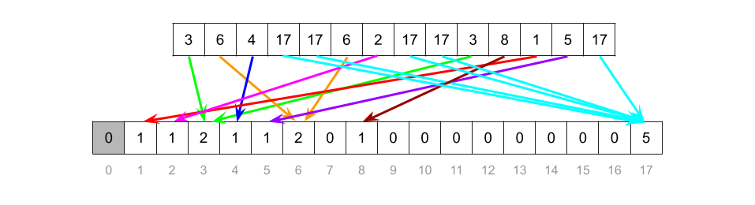

We can then process the buckets as shown in the following animation.



|  |
| --- |
| class Solution {    public int lastStoneWeight(int[] stones) {    // Set up the bucket array.  int maxWeight = stones[0];  for (int stone: stones) {  maxWeight = Math.max(maxWeight, stone);  }  int[] buckets = new int[maxWeight + 1];  // Bucket sort.  for (int weight : stones) {  buckets[weight]++;  }  // Scan through the buckets.  int biggestWeight = 0;  int currentWeight = maxWeight;  while (currentWeight > 0) {  if (buckets[currentWeight] == 0) {  currentWeight--;  } else if (biggestWeight == 0) {  buckets[currentWeight] %= 2;  if (buckets[currentWeight] == 1) {  biggestWeight = currentWeight;  }  currentWeight--;  } else {  buckets[currentWeight]--;  if (biggestWeight - currentWeight <= currentWeight) {  buckets[biggestWeight - currentWeight]++;  biggestWeight = 0;  } else {  biggestWeight -= currentWeight;  }  }  }  return biggestWeight;  }  } |

**Complexity Analysis**

* Time complexity : O(N + W)*O*(*N*+*W*).

Putting the N*N* stones of the input array into the bucket array is O(N)*O*(*N*), because inserting each stone is an O(1)*O*(1) operation.

In the worst case, the main loop iterates through all of the W*W* indexes of the bucket array. Processing each bucket is an O(1)*O*(1) operation. This, therefore, is O(W)*O*(*W*).

Seeing as we don't know which is larger out of N*N* and W*W*, we get a total of O(N + W)*O*(*N*+*W*).

Technically, this algorithm is pseudo-polynomial, as its time complexity is dependent on the numeric value of the input. Pseudo-polynomial algorithms are useful when there is no "true" polynomial alternative, but in situations such as this one where we have an O(N \, \log \, N)*O*(*N*log*N*) alternative (Approach 3), they are only useful for very specific inputs.

With the small values of W*W* that your code is tested against for this question here on LeetCode, this approach turns out to be faster than Approach 3. But that does not make it the better approach.

* Space complexity : O(W)*O*(*W*).

We allocated a new array of size W*W*.

When I looked through the discussion forum for this question, I was surprised to see a number of people arguing that this approach is O(N)*O*(*N*), on the basis that we could say W*W* is a constant, due to the problem description stating it has a maximum value of 10001000. The trouble with this argument is that N*N* also has a maximum specified (of 3030, in fact), and so it is arbitrary to argue that W*W* is a constant, yet N*N* is not. These constraints on LeetCode problems are intended to help you determine whether or not your algorithm will be fast enough. They are not supposed to imply some variables can be treated as "constants". A correct time/ space complexity should treat them as unbounded.

**Contiguous Array**

Given a binary array, find the maximum length of a contiguous subarray with equal number of 0 and 1.

**Example 1:**

**Input:** [0,1]

**Output:** 2

**Explanation:** [0, 1] is the longest contiguous subarray with equal number of 0 and 1.

**Example 2:**

**Input:** [0,1,0]

**Output:** 2

**Explanation:** [0, 1] (or [1, 0]) is a longest contiguous subarray with equal number of 0 and 1.

**Note:** The length of the given binary array will not exceed 50,000.

## Solution

#### **Approach #1 Brute Force [Time Limit Exceeded]**

**Algorithm**

The brute force approach is really simple. We consider every possible subarray within the given array and count the number of zeros and ones in each subarray. Then, we find out the maximum size subarray with equal no. of zeros and ones out of them.

|  |
| --- |
| public class Solution {  public int findMaxLength(int[] nums) {  int maxlen = 0;  for (int start = 0; start < nums.length; start++) {  int zeroes = 0, ones = 0;  for (int end = start; end < nums.length; end++) {  if (nums[end] == 0) {  zeroes++;  } else {  ones++;  }  if (zeroes == ones) {  maxlen = Math.max(maxlen, end - start + 1);  }  }  }  return maxlen;  }  } |

**Complexity Analysis**

* Time complexity : O(n^2)*O*(*n*2). We consider every possible subarray by traversing over the complete array for every start point possible.
* Space complexity : O(1)*O*(1). Only two variables zeroes*zeroes* and ones*ones* are required.

#### **Approach #2 Using Extra Array [Accepted]**

**Algorithm**

In this approach, we make use of a count*count* variable, which is used to store the relative number of ones and zeros encountered so far while traversing the array. The count*count* variable is incremented by one for every \text{1}1 encountered and the same is decremented by one for every \text{0}0 encountered.

We start traversing the array from the beginning. If at any moment, the count*count* becomes zero, it implies that we've encountered equal number of zeros and ones from the beginning till the current index of the array(i*i*). Not only this, another point to be noted is that if we encounter the same count*count* twice while traversing the array, it means that the number of zeros and ones are equal between the indices corresponding to the equal count*count* values. The following figure illustrates the observation for the sequence [0 0 1 0 0 0 1 1]:

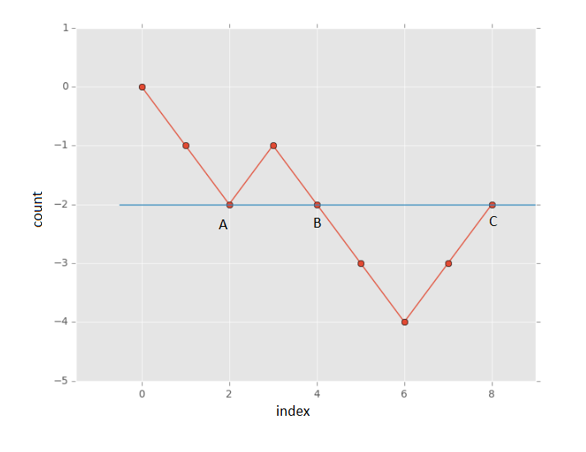

In the above figure, the subarrays between (A,B), (B,C) and (A,C) (lying between indices corresponing to count = 2*count*=2) have equal number of zeros and ones.

Another point to be noted is that the largest subarray is the one between the points (A, C). Thus, if we keep a track of the indices corresponding to the same count*count* values that lie farthest apart, we can determine the size of the largest subarray with equal no. of zeros and ones easily.

Now, the count*count* values can range between \text{-n}-n to \text{+n}+n, with the extreme points corresponding to the complete array being filled with all 0's and all 1's respectively. Thus, we make use of an array arr*arr*(of size \text{2n+1}2n+1to keep a track of the various count*count*'s encountered so far. We make an entry containing the current element's index (i*i*) in the arr*arr* for a new count*count* encountered everytime. Whenever, we come across the same count*count* value later while traversing the array, we determine the length of the subarray lying between the indices corresponding to the same count*count* values.

|  |
| --- |
| public class Solution {  public int findMaxLength(int[] nums) {  int[] arr = new int[2 * nums.length + 1];  Arrays.fill(arr, -2);  arr[nums.length] = -1;  int maxlen = 0, count = 0;  for (int i = 0; i < nums.length; i++) {  count = count + (nums[i] == 0 ? -1 : 1);  if (arr[count + nums.length] >= -1) {  maxlen = Math.max(maxlen, i - arr[count + nums.length]);  } else {  arr[count + nums.length] = i;  }  }  return maxlen;  }  } |

**Complexity Analysis**

* Time complexity : O(n)*O*(*n*). The complete array is traversed only once.
* Space complexity : O(n)*O*(*n*). arr*arr* array of size \text{2n+1}2n+1 is used.

#### **Approach #3 Using HashMap [Accepted]**

**Algorithm**

This approach relies on the same premise as the previous approach. But, we need not use an array of size \text{2n+1}2n+1, since it isn't necessary that we'll encounter all the count*count* values possible. Thus, we make use of a HashMap map*map* to store the entries in the form of (index, count)(*index*,*count*). We make an entry for a count*count* in the map*map* whenever the count*count* is encountered first, and later on use the correspoding index to find the length of the largest subarray with equal no. of zeros and ones when the same count*count* is encountered again.

The following animation depicts the process:



|  |
| --- |
| public class Solution {  public int findMaxLength(int[] nums) {  Map<Integer, Integer> map = new HashMap<>();  map.put(0, -1);  int maxlen = 0, count = 0;  for (int i = 0; i < nums.length; i++) {  count = count + (nums[i] == 1 ? 1 : -1);  if (map.containsKey(count)) {  maxlen = Math.max(maxlen, i - map.get(count));  } else {  map.put(count, i);  }  }  return maxlen;  }  } |

**Complexity Analysis**

* Time complexity : O(n)*O*(*n*). The entire array is traversed only once.
* Space complexity : O(n)*O*(*n*). Maximum size of the HashMap map*map* will be \text{n}n, if all the elements are either 1 or 0.

**Perform String Shifts**

You are given a string s containing lowercase English letters, and a matrix shift, where shift[i] = [direction, amount]:

* direction can be 0 (for left shift) or 1 (for right shift).
* amount is the amount by which string s is to be shifted.
* A left shift by 1 means remove the first character of s and append it to the end.
* Similarly, a right shift by 1 means remove the last character of s and add it to the beginning.

Return the final string after all operations.

**Example 1:**

**Input:** s = "abc", shift = [[0,1],[1,2]]

**Output:** "cab"

**Explanation:**

[0,1] means shift to left by 1. "abc" -> "bca"

[1,2] means shift to right by 2. "bca" -> "cab"

**Example 2:**

**Input:** s = "abcdefg", shift = [[1,1],[1,1],[0,2],[1,3]]

**Output:** "efgabcd"

**Explanation:**

[1,1] means shift to right by 1. "abcdefg" -> "gabcdef"

[1,1] means shift to right by 1. "gabcdef" -> "fgabcde"

[0,2] means shift to left by 2. "fgabcde" -> "abcdefg"

[1,3] means shift to right by 3. "abcdefg" -> "efgabcd"

**Constraints:**

* 1 <= s.length <= 100
* s only contains lower case English letters.
* 1 <= shift.length <= 100
* shift[i].length == 2
* 0 <= shift[i][0] <= 1
* 0 <= shift[i][1] <= 100

 Hide Hint #1

Intuitively performing all shift operations is acceptable due to the constraints.

   Hide Hint #2

You may notice that left shift cancels the right shift, so count the total left shift times (may be negative if the final result is right shift), and perform it once.

## Solution

#### **Approach 1: Simulation**

**Intuition**

When given a shift operation, for example [1, 4], we'll refer to the first part as the shift-direction, and the second part as the shift-amount.

The most obvious way of solving this problem is to simulate the shifts, one by one.

For example, suppose we have the string "leetcodeiscool".

If we need to perform shift operation [0, 5], then we'll shift the string left by 5, i.e.:



And if we need to perform shift operation [1, 5], then we'll shift the string *right* by 5, i.e.:



We could write an algorithm that simulates the process in the animation for each shift operation. However, strings are immutable in many programming languages, including Java and Python. This means that once a string object has been created, it *cannot be modified*. Instead, a *new string* must be created if we want to change it. This makes "string modification" a very expensive operation, at O(L)*O*(*L*), where L*L* is the length of the string. Therefore, we don't want to make lots of little modifications: we want to combine them into one single modification that can be applied with a single new string creation.

So, how can we do that here? Well, observe that a *left shift* is equivalent to taking *shift-amount* letters off the front, and putting them onto the end. Similarly, a *right shift* is equivalent to taking *shift-amount* letters off the end, and putting them onto the front.

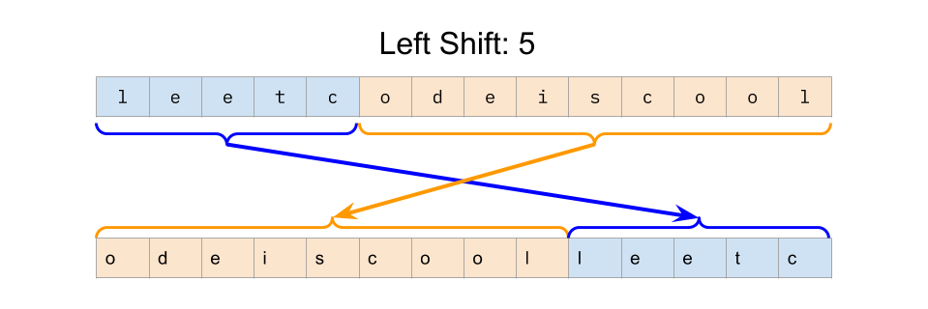

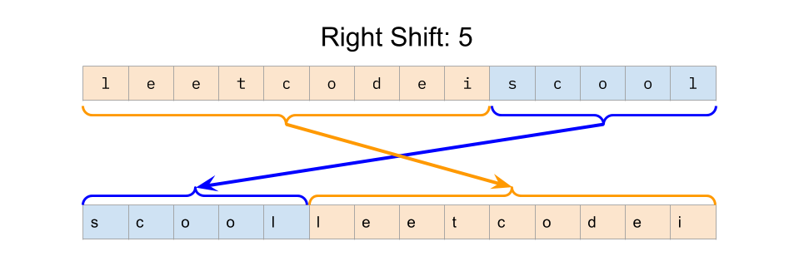

This will work as long as *shift-amount* is *less than the length of the string*.

However, *shift-amounts* are allowed to be *longer* than the length of the string. For example, consider the word "cabbage" (which has seven letters). We need to apply the *right-shift* operation [1, 9] to it. If the word was more than nine letters long, we would have just taken nine letters off the end, and put them on the front. But there aren't nine letters to move! To find a solution, let's start by going back to the inefficient algorithm; moving the string by one position at a time.



Notice that after seven shifts we're back to "cabbage" again. Only the last two shifts mattered. The number seven is significant because it is the length of the input string. We can extend this a bit further by reasoning that if we had a *shift-amount* of 25, then we'd effectively have 7 + 7 + 7 + 4. The 7's will do nothing, and it is only the final 4 that the string will be shifted by.

Recognize that the "remainder" after subtracting the length as many times as we can is simply taking the modulus of a number. i.e. 9 % 7 = 2 and 25 % 7 = 4.

Therefore, if the *shift-amount* is greater than the length of the string, then we should start by reducing the *shift-amount* to modulo the length of the string. In fact, we don't even need the "if". For example, 6 % 7 = 6. The modulo does nothing if the first number is smaller than the second.

To put this into a complete algorithm that solves the problem, we need to loop through the list of shift operations, doing a single concatenation for each one. Here is an animation of this process.



|  |
| --- |
| class Solution {  public String stringShift(String string, int[][] shift) {  int len = string.length();  for (int[] move : shift) {  int direction = move[0];  int amount = move[1] % len;  if (direction == 0) {  // Move necessary amount of characters from front to end  string = string.substring(amount) + string.substring(0, amount);  } else {  // Move necessary amount of characters from end to front  string = string.substring(len - amount) + string.substring(0, len - amount);  }  }  return string;  }  } |

**Complexity Analysis**

Let L*L* be the length of the string and N*N* be the length of the shift array.

* Time complexity : O(N \cdot L)*O*(*N*⋅*L*).

Making a single modification to the input string has a cost of O(L)*O*(*L*), as we need to create a new string with the modifications. We are making one modification for each shift operation. As there are N*N* shift operations, this gives us a total time complexity of O(N \cdot L)*O*(*N*⋅*L*).

* Space complexity : O(L)*O*(*L*).

While performing a string modification, we'll have both the original string and the new string in memory. Therefore, the space complexity is O(L)*O*(*L*).

Note that if you're using a language with mutable strings (such as C or C++), then it is possible to get the space complexity down to O(1)*O*(1) by doing the shift operations in-place with a suitable algorithm. Approach 3 or 4 of the [Rotate Strings Solution Article](https://leetcode.com/problems/rotate-array/solution/) would be a great way of going about this.

Before we came up with this approach, we briefly discussed a simpler approach where instead of doing each shift operation as a single string modification, we'd do it as shift-amount operations. What would the time complexity for this approach be? To simplify, we'll assume that shift-amount must be less than or equal to L*L* (we can use the modulo operator to ensure this). Under this assumption, the worst case is where all the shift-amounts are exactly L - 1*L*−1. This means that applying a shift operation will do a O(L)*O*(*L*) string modification, L-1*L*−1 times. (S - 1) \cdot O(L) = O(L^2)(*S*−1)⋅*O*(*L*)=*O*(*L*2). Then with N*N* shift operations to perform, we get a total of O(N \cdot L ^ 2)*O*(*N*⋅*L*2). This is a lot worse!

#### **Approach 2: Compute Net Shift**

**Intuition**

In Approach 1, we calculated each shift at a cost of O(L)*O*(*L*) each time (where L*L* is the length of the input string). However, you might've noticed that we can combine all the shifts, and then perform a single string modification for all of them.

For example, if we have two left shifts, [0, 3] and [0, 6], then we can combine them into a single left shift [0, 3 + 6] = [0, 9]. Then, instead of performing two separate O(L)*O*(*L*) modifications, we can perform just one.

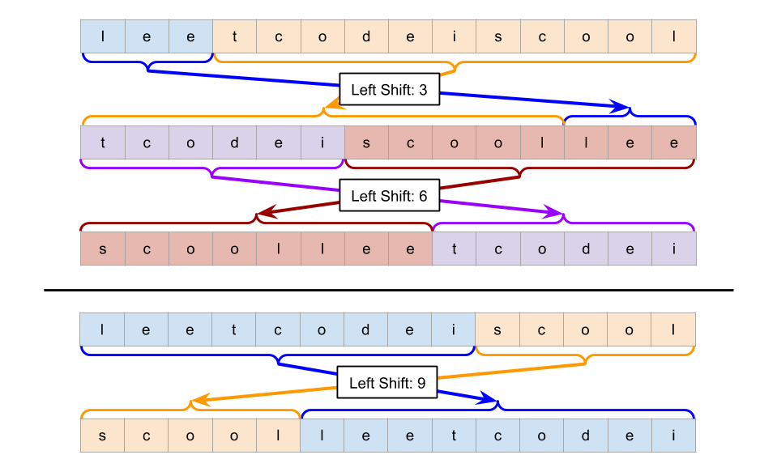

The same idea applies to the right shifts.

We could, therefore, add all the lefts together and apply them, and then add all the rights together, and apply them. This would mean we only needed to perform two O(L)*O*(*L*) string modifications.



We can do even better than this though, as *left shifts and right shifts cancel each other out*. For example, a *left shift* by 3, followed by a *right shift* by 3, brings us back to the original string. It is, therefore, wasted computation to do these shift operations at all!

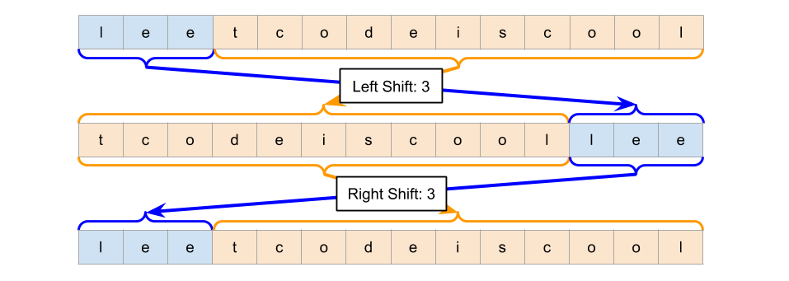

What about a *right shift* by 5, followed by a *left shift* by 3?

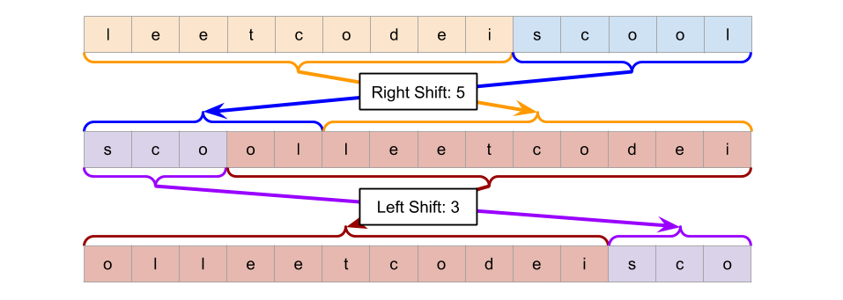

In effect, we are left with a *right shift* by 2.

So for this approach, we'll write an algorithm that pre-processes the shift list, and then applies a single string modification.

**Algorithm**

As described above, we should go through the shift list adding up all the *right shift-amounts* and *left shift-amounts* into two separate sums.

And then once we have these two amounts, we need to work out which is bigger, and partially cancel it out with the other. We then need to do the relevant shift with what's remaining. If both are the same, then the string won't be changed at all.

Here is the code for this algorithm. After this code, we'll look at a slight optimization/ simplification, that uses a little more math.

|  |
| --- |
| class Solution {  public String stringShift(String string, int[][] shift) {    // Add up the left shifts and right shifts.  int[] overallShifts = new int[2];  for (int[] move : shift) {  overallShifts[move[0]] += move[1];  }  int leftShifts = overallShifts[0];  int rightShifts = overallShifts[1];    // Determine which shift (if any) to perform.  int len = string.length();  if (leftShifts > rightShifts) {  leftShifts = (leftShifts - rightShifts) % len;  string = string.substring(leftShifts) + string.substring(0, leftShifts);  }  else if (rightShifts > leftShifts) {  rightShifts = (rightShifts - leftShifts) % len;  string = string.substring(len - rightShifts) + string.substring(0, len - rightShifts);  }    return string;  }  } |

To simplify the code further, remember that *right shifts* and *left shifts* cancel each other out. We'll just keep track of how many *left shifts* there are, by treating *right shifts* as negative *left shifts*.

If after doing this, the final value of left_shifts is positive, then we need to do a *left shift operation*. If it is negative, then we need to do a *right shift operation*, i.e. if it is -5, then we need to *right shift* by 5.

We can simplify it further still by recognizing that the number of *right shifts* can be converted into a number of *left shifts*. Notice that all "valid" shifts of a string can be represented in a clock-like circle. For example, here is the "clock" diagram we could make for the word "leetcode".

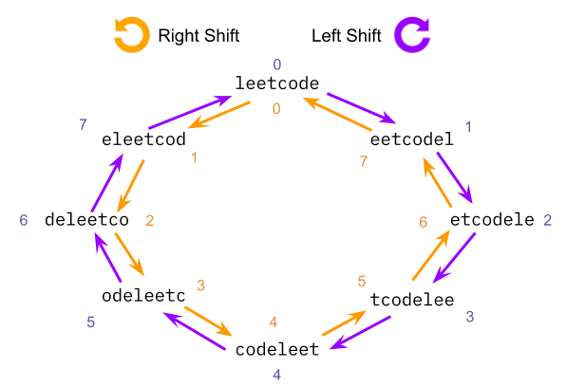

When we *left shift* the string, we are moving clockwise. When we *right shift* the string, we are moving anti-clockwise.

Now to get the overall left shift, we can simply take the total *left shifts* (regardless of whether it is positive or negative) modulo the length of the string:

left_shifts = left_shifts % length of string

In most programming languages, the modulo operator will add length to the shift amount until the result is positive. This is what we want. Note that the % operator doesn't work this way in *all* languages. In some languages, such as Java, *it does not make negative numbers positive*. Java's Math.floorMod function will do what we want though.

|  |
| --- |
| class Solution {  public String stringShift(String s, int[][] shift) {  // Count the number of left shifts. A right shift is a negative left shift.  int leftShifts = 0;  for (int[] move : shift) {  if (move[0] == 1) {  move[1] = - move[1];  }  leftShifts += move[1];  }    // Convert back to a positive, do left shifts, and return.  leftShifts = Math.floorMod(leftShifts, s.length());  s = s.substring(leftShifts) + s.substring(0, leftShifts);  return s;  }  } |

**Complexity Analysis**

Let L*L* be the length of the string and N*N* be the length of the shift array. Both sub-approaches here have the same complexity analysis.

* Time complexity : O(N + L)*O*(*N*+*L*).

The algorithms presented in Approach 2 both break the task into two sub-steps: calculating an overall shift and applying the shift. We'll analyze these one at a time and then combine the results.

The first step loops through each of the N*N* entries in the shift array, adding up the total number of left shifts and the total number of right shifts. Handling each entry is an O(1)*O*(1) operation, so this first step has a total cost of O(N)*O*(*N*).

The second step applies a single string-shift operation. As discussed in the previous approach, a string-shift operation has a cost of O(L)*O*(*L*).

Because we are doing these steps one-after-the-other, and we don't know whether N*N* or L*L* is bigger, we add them to get a final time complexity of O(N + L)*O*(*N*+*L*).

* Space complexity : O(L)*O*(*L*).

The first step uses constant extra space to keep track of the counts. This leaves us with the space complexity of modifying a string, which, as discussed before, requires auxiliary space of O(L)*O*(*L*).

As stated in the previous approach, it is possible to get the space complexity down to O(1)*O*(1) by using a language with mutable strings.

**Construct Binary Search Tree from Preorder Traversal**

Return the root node of a binary **search** tree that matches the given preorder traversal.

(Recall that a binary search tree is a binary tree where for every node, any descendant of *node.left* has a value *<* *node.val*, and any descendant of *node.right* has a value *>* *node.val*.  Also recall that a preorder traversal displays the value of the *node* first, then traverses *node.left*, then traverses *node.right*.)

It's guaranteed that for the given test cases there is always possible to find a binary search tree with the given requirements.

**Example 1:**

**Input:** [8,5,1,7,10,12]

**Output:** [8,5,10,1,7,null,12]

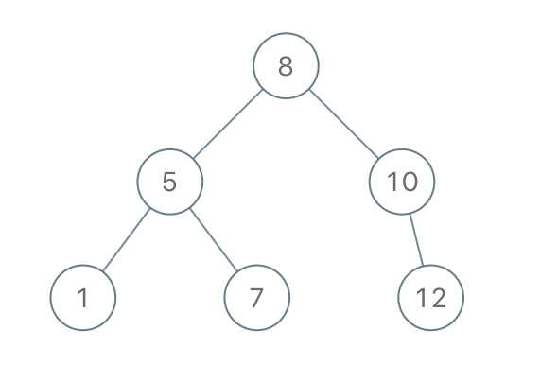

**Constraints:**

* 1 <= preorder.length <= 100
* 1 <= preorder[i] <= 10^8
* The values of preorder are distinct.

## Solution

#### **Approach 1: Construct binary tree from preorder and inorder traversal**

**Intuition**

This approach is not the optimal one because of \mathcal{O}(N \log N)O(*N*log*N*) time complexity, but very straightforward.

Let's use here two facts:

* [Binary tree could be constructed from preorder and inorder traversal](https://leetcode.com/articles/construct-binary-tree-from-preorder-and-inorder-tr/).
* [Inorder traversal of BST is an array sorted in the ascending order](https://leetcode.com/articles/delete-node-in-a-bst/).

**Algorithm**

* Construct inorder traversal by sorting the preorder array.
* [Construct binary tree from preorder and inorder traversal](https://leetcode.com/articles/construct-binary-tree-from-preorder-and-inorder-tr/): the idea is to peek the elements one by one from the preorder array and try to put them as a left or as a right child if it's possible. If it's impossible - just put null as a child and proceed further. The possibility to use an element as a child is checked by an inorder array: if it contains no elements for this subtree, then the element couldn't be used here, and one should use null as a child instead.

**Implementation**

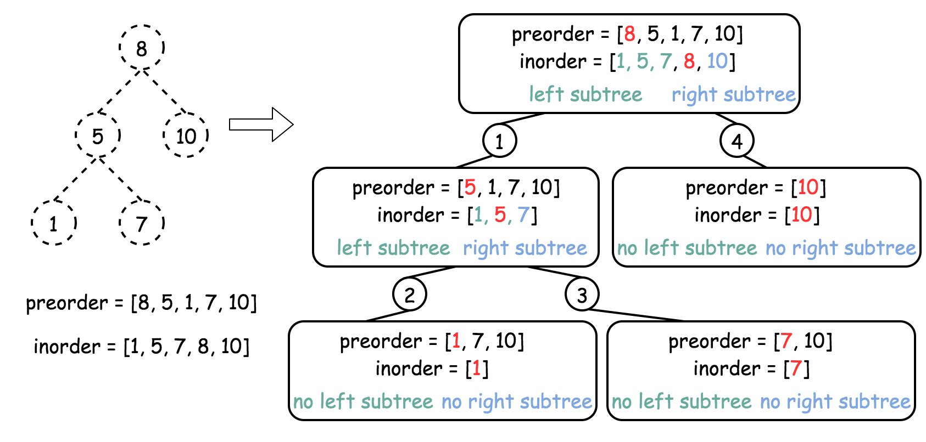

|  |
| --- |
| class Solution {  // start from first preorder element  int pre_idx = 0;  int[] preorder;  HashMap<Integer, Integer> idx_map = new HashMap<Integer, Integer>();  public TreeNode helper(int in_left, int in_right) {  // if there is no elements to construct subtrees  if (in_left == in_right)  return null;  // pick up pre_idx element as a root  int root_val = preorder[pre_idx];  TreeNode root = new TreeNode(root_val);  // root splits inorder list  // into left and right subtrees  int index = idx_map.get(root_val);  // recursion  pre_idx++;  // build left subtree  root.left = helper(in_left, index);  // build right subtree  root.right = helper(index + 1, in_right);  return root;  }  public TreeNode bstFromPreorder(int[] preorder) {  this.preorder = preorder;  int [] inorder = Arrays.copyOf(preorder, preorder.length);  Arrays.sort(inorder);  // build a hashmap value -> its index  int idx = 0;  for (Integer val : inorder)  idx_map.put(val, idx++);  return helper(0, inorder.length);  }  } |

**Complexity Analysis**

* Time complexity : \mathcal{O}(N \log N)O(*N*log*N*). \mathcal{O}(N \log N)O(*N*log*N*) to sort preorder array and \mathcal{O}(N)O(*N*) to construct the binary tree.
* Space complexity : \mathcal{O}(N)O(*N*) the inorder traversal and the tree.

#### **Approach 2: Recursion**

**Intuition**

It's quite obvious that the best possible time complexity for this problem is \mathcal{O}(N)O(*N*) and hence the approach 1 is not the best one.

Basically, the inorder traversal above was used only to check if the element could be placed in this subtree. Since one deals with a BST here, this could be verified with the help of lower and upper limits for each element as for the [validate BST problem](https://leetcode.com/articles/validate-binary-search-tree/). This way there is no need in inorder traversal and the time complexity is \mathcal{O}(N)O(*N*).

**Algorithm**

* Initiate the lower and upper limits as negative and positive infinity because one could always place the root.
* Start from the first element in the preorder array idx = 0.
* Return helper(lower, upper):
  + If the preorder array is used up idx = n then the tree is constructed, return null.
  + If current value val = preorder[idx] is smaller then lower limit, or larger than upper limit, return null.
  + If the current value is in the limits, place it here root = TreeNode(val) and proceed to construct recursively left and right subtrees: root.left = helper(lower, val) and root.right = helper(val, upper).
  + Return root.

**Implementation**

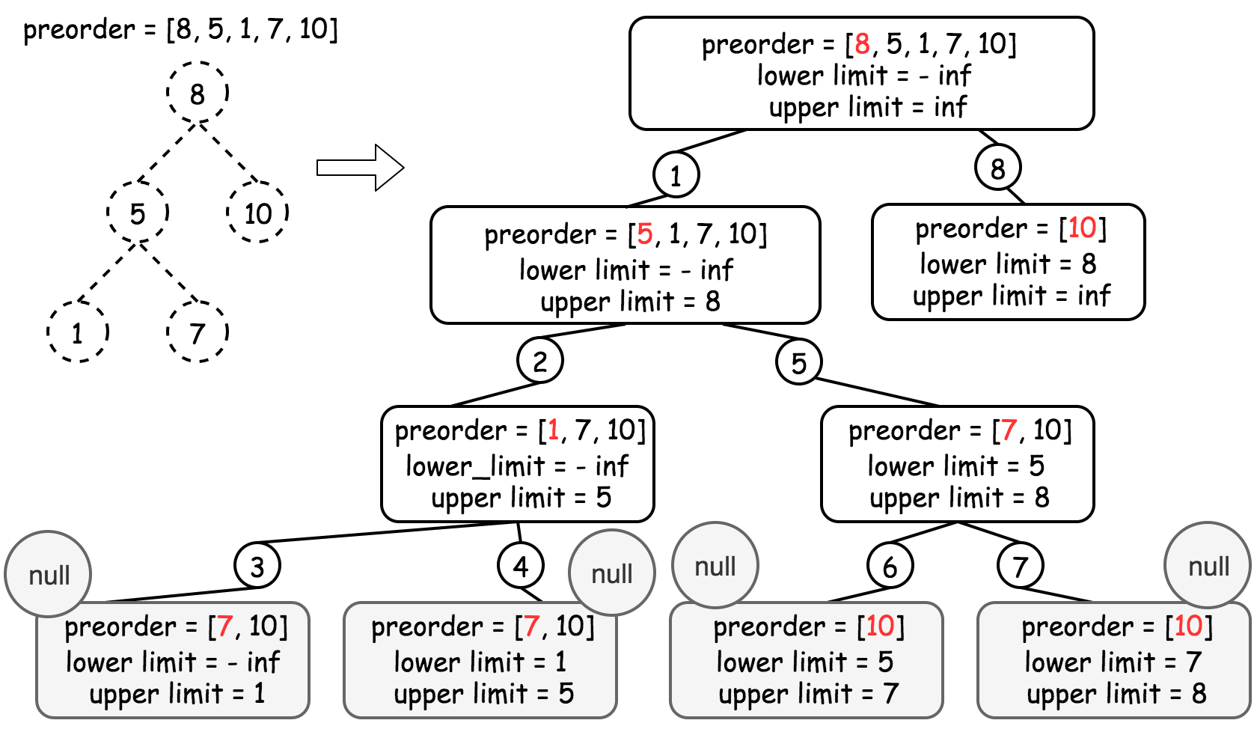

|  |
| --- |
| class Solution {  int idx = 0;  int[] preorder;  int n;  public TreeNode helper(int lower, int upper) {  // if all elements from preorder are used  // then the tree is constructed  if (idx == n) return null;  int val = preorder[idx];  // if the current element  // couldn't be placed here to meet BST requirements  if (val < lower || val > upper) return null;  // place the current element  // and recursively construct subtrees  idx++;  TreeNode root = new TreeNode(val);  root.left = helper(lower, val);  root.right = helper(val, upper);  return root;  }  public TreeNode bstFromPreorder(int[] preorder) {  this.preorder = preorder;  n = preorder.length;  return helper(Integer.MIN_VALUE, Integer.MAX_VALUE);  }  } |

**Complexity Analysis**

* Time complexity : \mathcal{O}(N)O(*N*) since we visit each node exactly once.
* Space complexity : \mathcal{O}(N)O(*N*) to keep the entire tree.

#### **Approach 3: Iteration**

**Algorithm**

The recursion above could be converted into the iteration with the help of stack.

* Pick the first preorder element as a root root = new TreeNode(preorder[0]) and push it into stack.
* Use for loop to iterate along the elements of preorder array :
  + Pick the last element of the stack as a parent node, and the the current element of preorder as a child node.
  + Adjust the parent node : pop out of stack all elements with the value smaller than the child value. Change the parent node at each pop node = stack.pop().
  + If node.val < child.val - put the child as a right child of the node : node.right = child.
  + Else - as a left child : node.left = child.
  + Push child node into the stack.
* Return root.

**Implementation**



|  |
| --- |
| class Solution {  public TreeNode bstFromPreorder(int[] preorder) {  int n = preorder.length;  if (n == 0) return null;  TreeNode root = new TreeNode(preorder[0]);  Deque<TreeNode> deque = new ArrayDeque<TreeNode>();  deque.push(root);  for (int i = 1; i < n; i++) {  // take the last element of the deque as a parent  // and create a child from the next preorder element  TreeNode node = deque.peek();  TreeNode child = new TreeNode(preorder[i]);  // adjust the parent  while (!deque.isEmpty() && deque.peek().val < child.val)  node = deque.pop();  // follow BST logic to create a parent-child link  if (node.val < child.val) node.right = child;  else node.left = child;  // add the child into deque  deque.push(child);  }  return root;  }  } |

**Complexity Analysis**

* Time complexity : \mathcal{O}(N)O(*N*) since we visit each node exactly once.
* Space complexity : \mathcal{O}(N)O(*N*) to keep the stack and the tree.

Please stop using Stack class in Java. Here ([leetcode.com/problems/flatten-nested-list-iterator/discuss/80147/Simple-Java-solution-using-a-stack-with-explanation/165585](http://leetcode.com/problems/flatten-nested-list-iterator/discuss/80147/Simple-Java-solution-using-a-stack-with-explanation/165585)) you can find a great explanation of why it's a bad idea and it might even cost you an offer.  
There's an unhealthy obsession with Stack and LinkedList classes on Leetcode - 2 classes that nobody uses in real life.

**Leftmost Column with at Least a One**

(This problem is an ***interactive problem***.)

A **row-sorted binary matrix** means that all elements are 0 or 1 and each row of the matrix is sorted in non-decreasing order.

Given a **row-sorted binary matrix** binaryMatrix, return the index (0-indexed) of the ***leftmost column*** with a 1 in it. If such an index does not exist, return -1.

**You can't access the Binary Matrix directly.** You may only access the matrix using a BinaryMatrix interface:

* BinaryMatrix.get(row, col) returns the element of the matrix at index (row, col) (0-indexed).
* BinaryMatrix.dimensions() returns the dimensions of the matrix as a list of 2 elements [rows, cols], which means the matrix is rows x cols.

Submissions making more than 1000 calls to BinaryMatrix.get will be judged Wrong Answer. Also, any solutions that attempt to circumvent the judge will result in disqualification.

For custom testing purposes, the input will be the entire binary matrix mat. You will not have access to the binary matrix directly.

**Example 1:**

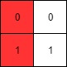

**Input:** mat = [[0,0],[1,1]]

**Output:** 0

**Example 2:**

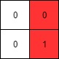

**Input:** mat = [[0,0],[0,1]]

**Output:** 1

**Example 3:**

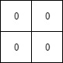

**Input:** mat = [[0,0],[0,0]]

**Output:** -1

**Example 4:**

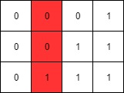

**Input:** mat = [[0,0,0,1],[0,0,1,1],[0,1,1,1]]

**Output:** 1

**Constraints:**

* rows == mat.length
* cols == mat[i].length
* 1 <= rows, cols <= 100
* mat[i][j] is either 0 or 1.
* mat[i] is sorted in non-decreasing order.

Hide Hint #1

1. (Binary Search) For each row do a binary search to find the leftmost one on that row and update the answer.

   Hide Hint #2

2. (Optimal Approach) Imagine there is a pointer p(x, y) starting from top right corner. p can only move left or down. If the value at p is 0, move down. If the value at p is 1, move left. Try to figure out the correctness and time complexity of this algorithm.

## Solution

#### **Approach 1: Linear Search Each Row**

**Intuition**

This approach won't pass, but we'll use it as a starting point. Also, it might be helpful to you if you just needed an example of how to use the API, but don't want to see a complete solution yet!

The leftmost 1 is the 1 with the lowest column index.

The problem can be broken down into finding the index of the first 1 in each row and then taking the minimum of those indexes.

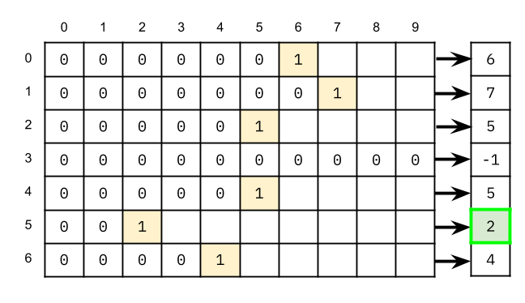

The simplest way of doing this would be a linear search on each row.

**Algorithm**

|  |
| --- |
| class Solution {  public int leftMostColumnWithOne(BinaryMatrix binaryMatrix) {  int rows = binaryMatrix.dimensions().get(0);  int cols = binaryMatrix.dimensions().get(1);  int smallestIndex = cols;  for (int row = 0; row < rows; row++) {  for (int col = 0; col < cols; col++) {  if (binaryMatrix.get(row, col) == 1) {  smallestIndex = Math.min(smallestIndex, col);  break;  }  }  }  return smallestIndex == cols ? -1 : smallestIndex;  }  } |

**Complexity Analysis**

If you ran this code, you would have gotten the following error.

You made too many calls to BinaryMatrix.get().

The maximum grid size is 100 by 100, so it would contain 10000 cells. In the worst case, the linear search algorithm we implemented has to check every cell. With the problem description telling us that we can only make up to 1000 API calls, this clearly isn't going to work.

Let N*N* be the number of rows, and M*M* be the number of columns.

* Time complexity : O(N \cdot M)*O*(*N*⋅*M*)

We don't know the time complexity of binaryMatrix.get() as its implementation isn't our concern. Therefore, we can assume it's O(1)*O*(1).

In the worst case, we are retrieving a value for each of the N \cdot M*N*⋅*M* cells. At O(1)*O*(1) per operation, this gives a total of O(N \cdot M)*O*(*N*⋅*M*).

* Space complexity : O(1)*O*(1).

We are only using constant extra space.

#### **Approach 2: Binary Search Each Row**

**Intuition**

This isn't the best approach, but it passes, and coding it up is a good opportunity to practice binary search.

When linear search is too slow, we should try to find a way to use binary search. If you're not familiar with binary search, [check out this Explore Card!](https://leetcode.com/explore/learn/card/binary-search/). We recommend doing the first couple of binary search questions to get familiar with the algorithm before coming back to this problem.

Also, have a go at [First Bad Version](https://leetcode.com/problems/first-bad-version/). The only difference between that problem and this one is that instead of 0 and 1, it uses false and true.

Like we did with the linear search, we're going to apply binary search independently on each row. The target element we're searching for is the first 1 in the row.

The core part of a binary search algorithm is how it decides whether the target element is to the left or the right of the middle element. Let's figure this out by thinking through a couple of examples.

In the row below, we've determined that the middle element is a 0. On what side must the target element (first 1) be? The left, or the right? Don't forget, all the 0's are before all the 1's.

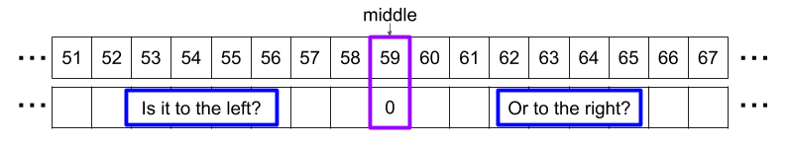

In this next row, the middle element is a 1? What side must the target element be on? Could it also possibly be the 1 we just found?

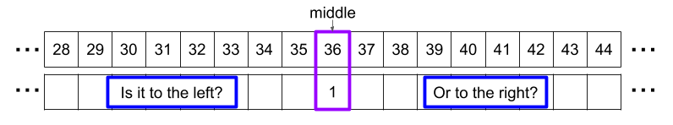

For the first example, we can conclude that the target element (if it exists) must be to the **right** of the middle element. This is because we know that everything to the left of a 0 must also be a 0,

For the second example, we can conclude that the target element is either the middle element itself or it is some other 1 to the **left** of the middle element. We know that everything to the right of a 1 is also a 1, but these can't possibly be further left than the one we just found.

In summary, if the middle element is a:

* **0**, then the target must be to the **right**.
* **1**, then the target is either this element or to the **left**.

We can then put this together into an algorithm that finds the index of the target element (first 1) in each row, and then returns the minimum of those indexes. Here is an animation of how that algorithm would look. The light grey numbers are the ones that we could infer without needing to make an API call. They are only there to help you understand.



**Algorithm**

If you're already quite familiar with binary search, feel free to skip down to the implementation below. I've decided to include lots of details here, as binary search is one of those algorithms that a lot of people get frustrated with easily and find it difficult to master.

In a binary search, we always keep track of the range that the target might be in by using two variables: lo to represent the lowest possible index it could be, and hi to represent the highest possible index it could be. Ignoring the binaryMatrix API details for the moment, here is a rough outline of our binary search in pseudocode.

define function binary_search(input_list):

lo = the lowest possible index

hi = the highest possible index

while the search space contains 2 or more items:

mid = the middle index in the remaining search space

if the element at input_list[mid] is 0:

lo = mid + 1 (the first 1 is *further right*, and can't be mid itself)

else:

hi = mid (the first 1 is either mid itself, *or is further left*)

return the only index remaining in the search space

As always in binary search, there are a couple more key implementation details we still need to deal with:

1. An even-length search space has two middles. Which do we choose?
2. The row might be all 0's.

Let's tackle these issues one at a time.

The first issue, the choice of middle, is important, as otherwise, the search space might stop shrinking when it gets down to two elements. When the search space doesn't shrink, the algorithm does the exact same thing the next loop cycle, resulting in an infinite loop. Remember that when the search space only contains two elements, they are the ones pointed to by lo and hi. This means that the lower middle equals lo, and the upper-middle equals hi. We, therefore, need to think about which cases would shrink the search space, and which would not.

If we use the lower-middle

* If it is a 0, then we set lo = mid + 1. Because hi == mid + 1, this means that lo == hi (search space is of length-one).
* If it is a 1, then we set hi = mid. Because mid == lo, this means that hi == lo (search space is of length-one).

If we use the upper-middle

* If it is a 0, then we set lo = mid + 1. Because hi = mid, we now have hi > lo (search space is of length-zero).
* If it is a 1, then we set hi = mid. Because hi == mid was already true, the search space stays as is (of length-two).

If we use the lower-middle, we know the search space will always shrink. If we use the upper-middle, it might not. Therefore, we should go with the lower-middle. The formula for this is mid = (low + high) / 2.

The second issue, a row of all zeroes, is solved by recognizing that the algorithm always shrinks down the search space to a single element. This is supposed to be the first 1, but if that doesn't exist, then it has to be a 0. Therefore, we can detect this case by checking whether or not the last element in the search space is a 1.

It is good practice to think these details through carefully so that you can write your binary search algorithm decisively and confidently. Resist the urge to [Program by Permutation](https://en.wikipedia.org/wiki/Programming_by_permutation)!

Anyway, putting this all together, we get the following code.

|  |
| --- |
| class Solution {  public int leftMostColumnWithOne(BinaryMatrix binaryMatrix) {  int rows = binaryMatrix.dimensions().get(0);  int cols = binaryMatrix.dimensions().get(1);  int smallestIndex = cols;  for (int row = 0; row < rows; row++) {  // Binary Search for the first 1 in the row.  int lo = 0;  int hi = cols - 1;  while (lo < hi) {  int mid = (lo + hi) / 2;  if (binaryMatrix.get(row, mid) == 0) {  lo = mid + 1;  }  else {  hi = mid;  }  }  // If the last element in the search space is a 1, then this row  // contained a 1.  if (binaryMatrix.get(row, lo) == 1) {  smallestIndex = Math.min(smallestIndex, lo);  }  }  // If smallest_index is still set to cols, then there were no 1's in  // the grid.  return smallestIndex == cols ? -1 : smallestIndex;  }  } |

**Complexity Analysis**

Let N*N* be the number of rows, and M*M* be the number of columns.

* Time complexity : O(N \, \log \, M)*O*(*N*log*M*).

There are M*M* items in each row. Therefore, each binary search will have a cost of O(\log \, M)*O*(log*M*). We are performing N*N* of these binary searches, giving a time complexity of N \cdot O(\log \, M) = O(N \, \log \, M)*N*⋅*O*(log*M*)=*O*(*N*log*M*).

* Space complexity : O(1)*O*(1).

We are using constant extra space.

#### **Approach 3: Start at Top Right, Move Only Left and Down**

**Intuition**

Did you notice in Approach 2 that we didn't need to finish searching all the rows? One example of this was row 3 on the example in the animation. At the point shown in the image below, it was clear that row 3 could not possibly be better than the minimum we'd found so far.

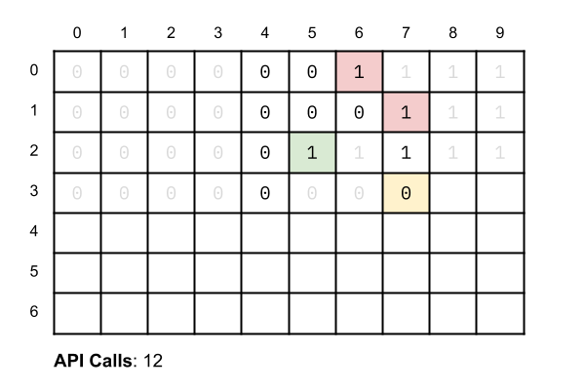

Therefore, an optimization we could have made was to keep track of the minimum index so far, and then abort the search on any rows where we have discovered a 0 at, or to the right of, that minimum index.

We can do even better than that; on each search, we can set hi = smallest_index - 1, where smallest_index is the smallest index of a 1 we've seen so far. In most cases, this is a substantial improvement. It works because we're only interested in finding 1s at lower indexes than we previously found. Here is an animation of the above example with this optimized algorithm. The algorithm eliminates as many cells as it can with each API call. It also starts by checking the last cell of the row before proceeding with the binary search, to eliminate needless binary searches where the row only had 0s left in it.



Here is what the worst-case looks like. Like before, its time complexity is still O(M \, \log \, N)*O*(*M*log*N*).

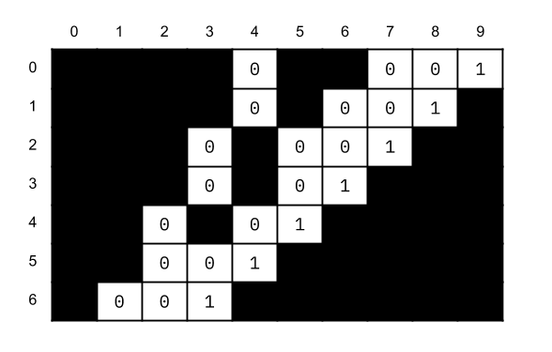

While this is no worse than Approach 2, there is a better algorithm.

Start in the top right corner, and if the current value is a 0, move down. If it is a 1, then move left.

The easiest way to see why this works is an example. Here is an animation of it.



You probably gained some intuitive sense as to why this works, just from watching the animation.

* When we encounter a 0, we know that the leftmost 1 can't be to the left of it.
* When we encounter a 1, we should continue the search on that row (move pointer to the left), in order to find an even smaller index.

**Algorithm**

|  |
| --- |
| class Solution {  public int leftMostColumnWithOne(BinaryMatrix binaryMatrix) {  int rows = binaryMatrix.dimensions().get(0);  int cols = binaryMatrix.dimensions().get(1);  // Set pointers to the top-right corner.  int currentRow = 0;  int currentCol = cols - 1;    // Repeat the search until it goes off the grid.  while (currentRow < rows && currentCol >= 0) {  if (binaryMatrix.get(currentRow, currentCol) == 0) {  currentRow++;  } else {  currentCol--;  }  }    // If we never left the last column, this is because it was all 0's.  return (currentCol == cols - 1) ? -1 : currentCol + 1;  }  } |

**Complexity Analysis**

Let N*N* be the number of rows, and M*M* be the number of columns.

* Time complexity : O(N + M)*O*(*N*+*M*).

At each step, we're moving 1 step left or 1 step down. Therefore, we'll always finish looking at either one of the M*M* rows or N*N* columns. Therefore, we'll stay in the grid for at most N + M*N*+*M* steps, and therefore get a time complexity of O(N + M)*O*(*N*+*M*).

* Space complexity : O(1)*O*(1).

We are using constant extra space.

**Bitwise AND of Numbers Range**

Given a range [m, n] where 0 <= m <= n <= 2147483647, return the bitwise AND of all numbers in this range, inclusive.

**Example 1:**

**Input:** [5,7]

**Output:** 4

**Example 2:**

**Input:** [0,1]

**Output:** 0

## Solution

#### **Overview**

First of all, one of the most intuitive solutions that one might come up with might be to iterate all the numbers ***one by one*** in the range and do the the bit AND operation to obtain the result.

This could work for test cases with a small range. Unfortunately it would exceed the time limit set by the online judge for test cases with a relative large range. In this article, we would illustrate some other solutions that do not require the iteration of all numbers.

First of all, let us look into the characteristic of the AND operation.

For a series of bits, e.g. [1, 1, 0, 1, 1], as long as there is one bit of zero value, then the result of AND operation on this series of bits would be zero.

Back to our problem, first we could represent each number in the range in its binary form which we could view as a string of binary numbers (e.g. 9 = 00001001). We then align the numbers according to the position of binary string.

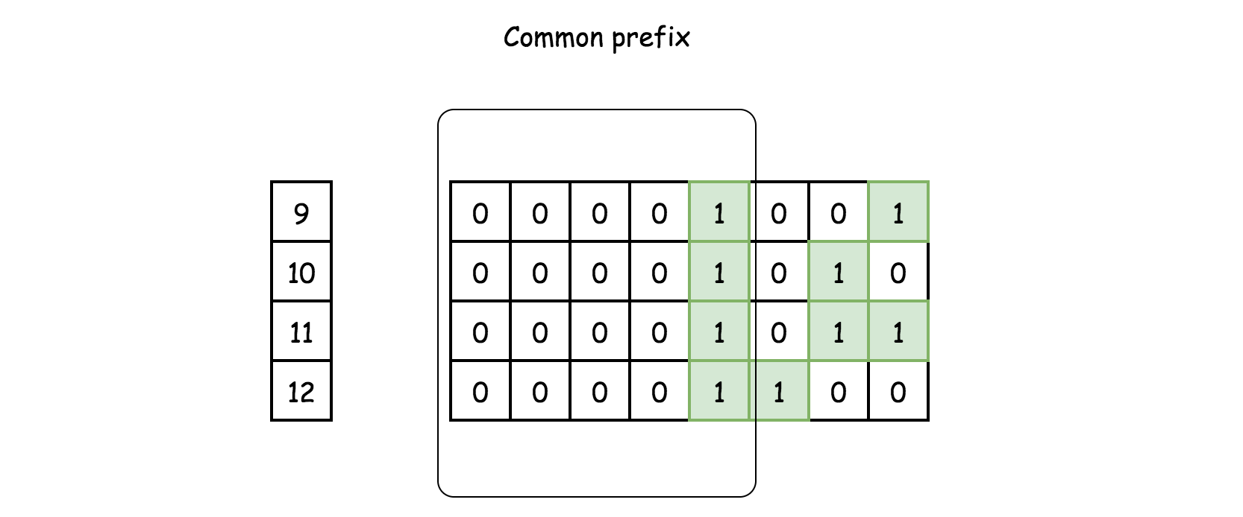

In the above example, one might notice that after the AND operation on all the numbers, the remaining part of bit strings is the ***common prefix*** of all these bit strings.

The final result asked by the problem consists of this common prefix of bit string as its left part, with the rest of bits as zeros.

More specifically, the common prefix of all these bit string is also the common prefix between the **starting** and **ending** numbers of the specified range (i.e. 9 and 12 respectively in the above example).

As a result, we then can reformulate the problem as "given two integer numbers, we are asked to find the ***common prefix*** of their binary strings."

#### **Approach 1: Bit Shift**

**Intuition**

Given the above intuition about the problem, our task is to calculate the common prefix for the bit strings of the two given numbers. One of the solutions would be to resort to the ***bit shift*** operation.

The idea is that we shift both numbers to the right, until the numbers become equal, i.e. the numbers are reduced into their common prefix. Then we append zeros to the common prefix in order to obtain the desired result, by shifting the common prefix to the left.

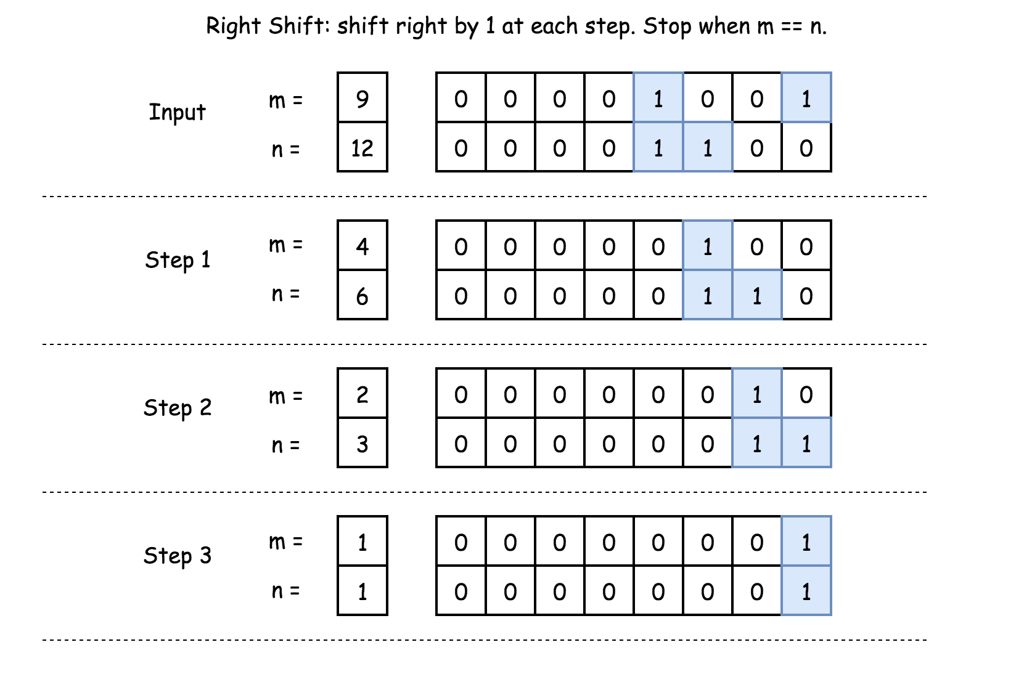

**Algorithm**

As stated in the intuition section, the algorithm consists of two steps:

* We reduce both numbers into their common prefix, by doing right shift iteratively. During the iteration, we keep the count on the number of shift operations we perform.
* With the common prefix, we restore it to its previous position, by left shifting.



|  |
| --- |
| class Solution {  public int rangeBitwiseAnd(int m, int n) {  int shift = 0;  // find the common 1-bits  while (m < n) {  m >>= 1;  n >>= 1;  ++shift;  }  return m << shift;  }  } |

**Complexity Analysis**

* Time Complexity: \mathcal{O}(1)O(1).
  + Although there is a loop in the algorithm, the number of iterations is bounded by the number of bits that an integer has, which is fixed.
  + Therefore, the time complexity of the algorithm is constant.
* Space Complexity: \mathcal{O}(1)O(1). The consumption of the memory for our algorithm is constant, regardless the input.

#### **Approach 2: Brian Kernighan's Algorithm**

**Intuition**

Speaking of bit shifting, there is another related algorithm called [Brian Kernighan's algorithm](http://graphics.stanford.edu/~seander/bithacks.html#CountBitsSetKernighan) which is applied to turn off the rightmost bit of one in a number.

The secret sauce of the Brian Kernighan's algorithm can be summarized as follows:

When we do AND bit operation between number and number-1, the rightmost bit of one in the original number would be turned off (from one to zero).

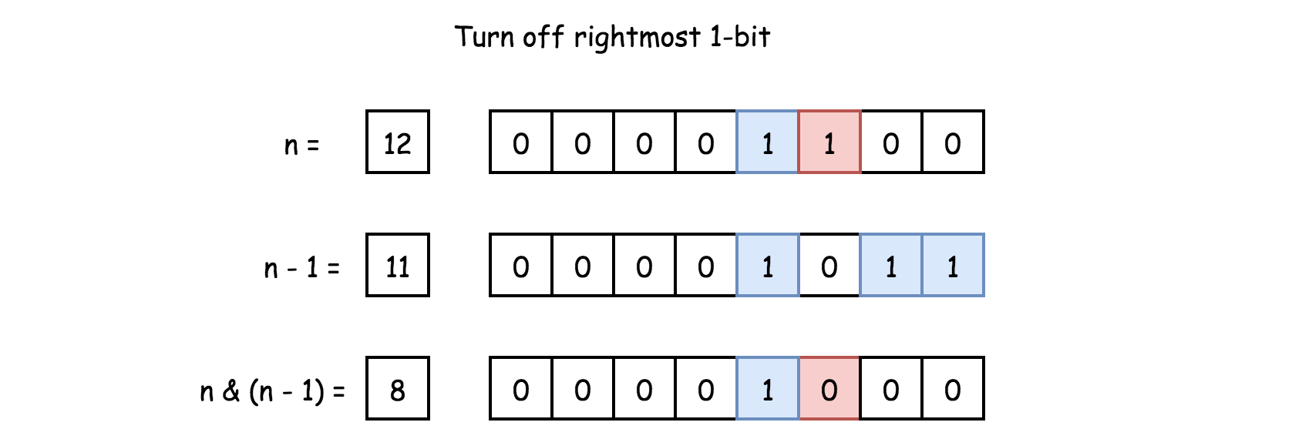

Based on the above trick, we could apply it to figure out the common prefix of two bit strings.

The idea is that for a given range [m, n][*m*,*n*] (i.e. m < n*m*<*n*), we could iteratively apply the trick on the number n*n* to turn off its rightmost bit of one until it becomes less or equal than the beginning of the range (m*m*), which we denote as n'*n*′. Finally, we do AND operation between n'*n*′ and m*m* to obtain the final result.

By applying the Brian Kernighan's algorithm, we basically turn off the bits that lies on the right side of the common prefix, from the ending number n*n*. With the rest of bits reset, we then can easily obtain the desired result.

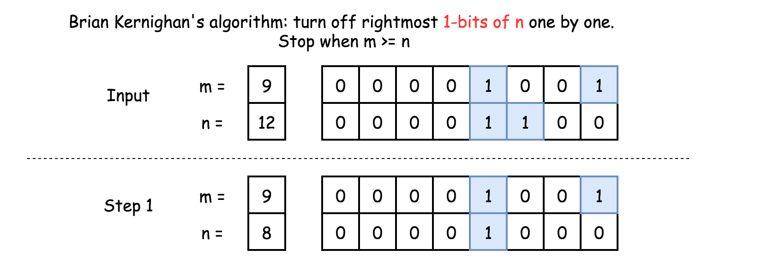

In the example (m=9, n=12) shown in the above figure, the common prefix would be 00001. After applying the Brian Kernighan's algorithm on the number n, its trailing 3 bits would all become zeros. Finally, we apply the AND operation between the reduced n and the m to obtain the common prefix.

**Algorithm**

|  |
| --- |
| class Solution {  public int rangeBitwiseAnd(int m, int n) {  while (m < n) {  // turn off rightmost 1-bit  n = n & (n - 1);  }  return m & n;  }  } |

By the way, one could refer to the problem called [Hamming distance](https://leetcode.com/articles/hamming-distance/) as another exercise to apply the Brian Kernighan's algorithm.

**Complexity Analysis**

* Time Complexity: \mathcal{O}(1)O(1).
  + Similar as the bit shift approach, the number of iteration in the algorithm is bounded by the number of bits in an integer number, which is constant.
  + Though having the same asymptotic complexity as the bit shift approach, the Brian Kernighan's algorithm requires less iterations, since it skips all the zero bits in between.
* Space Complexity: \mathcal{O}(1)O(1), since no additional memory is consumed by the algorithm.

**Longest Common Subsequence**

Given two strings text1 and text2, return the length of their longest common subsequence.

A subsequence of a string is a new string generated from the original string with some characters(can be none) deleted without changing the relative order of the remaining characters. (eg, "ace" is a subsequence of "abcde" while "aec" is not). A common subsequence of two strings is a subsequence that is common to both strings.

 If there is no common subsequence, return 0.

**Example 1:**

**Input:** text1 = "abcde", text2 = "ace"

**Output:** 3

**Explanation:** The longest common subsequence is "ace" and its length is 3.

**Example 2:**

**Input:** text1 = "abc", text2 = "abc"

**Output:** 3

**Explanation:** The longest common subsequence is "abc" and its length is 3.

**Example 3:**

**Input:** text1 = "abc", text2 = "def"

**Output:** 0

**Explanation:** There is no such common subsequence, so the result is 0.

**Constraints:**

* 1 <= text1.length <= 1000
* 1 <= text2.length <= 1000
* The input strings consist of lowercase English characters only.

Hide Hint #1

Try dynamic programming. DP[i][j] represents the longest common subsequence of text1[0 ... i] & text2[0 ... j].

   Hide Hint #2

DP[i][j] = DP[i - 1][j - 1] + 1 , if text1[i] == text2[j] DP[i][j] = max(DP[i - 1][j], DP[i][j - 1]) , otherwise

## Solution

#### **Overview**

This is a nice problem, as unlike some interview questions, this one is a real-world problem! Finding the longest common subsequence between two strings is useful for checking the difference between two files (diffing). Git needs to do this when merging branches. It's also used in genetic analysis (combined with other algorithms) as a measure of similarity between two genetic codes.

For that reason, the examples used in this article will be strings consisting of the letters a, c, g, and t. You might remember these letters from high school biology—they are the symbols we use to represent genetic codes. By using just four letters in examples, it is easier for us to construct interesting examples to discuss here. You don't need to know anything about genetics or biology for this though, so don't worry.

Before we look at approaches that do work, we'll have a quick look at some that do not. This is because we're going to pretend that you've just encountered this problem in an interview, and have never seen it before, and have not been told that it is a "dynamic programming problem". After all, in this interview scenario, most people won't realize immediately that this is a dynamic programming problem. Being able to approach and explore problems with an open mind without jumping to early conclusions is essential in tackling problems you haven't seen before.

**What is a Common Subsequence?**

Here's an example of two strings that we need to find the longest common subsequence of.

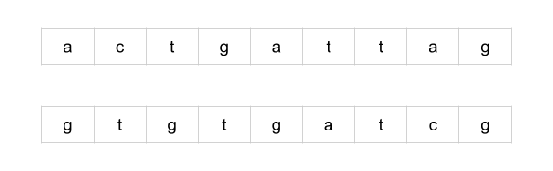

A common subsequence is a sequence of letters that appears in both strings. Not every letter in the strings has to be used, but letters cannot be rearranged. In essence, a subsequence of a string s is a string we get by deleting some letters in s.

Here are some of the common subsequences for the above example. To help show that the subsequence really is a common subsequence, we've drawn lines between the corresponding characters.

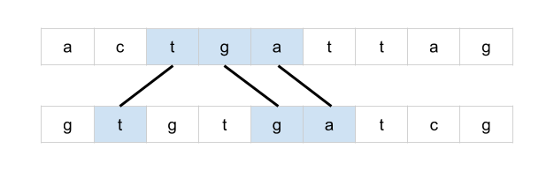 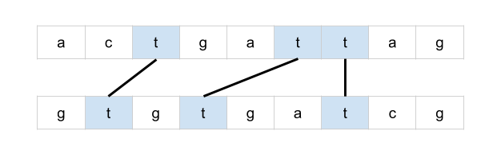 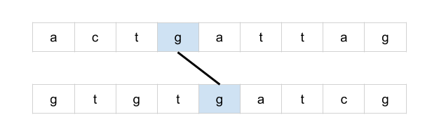 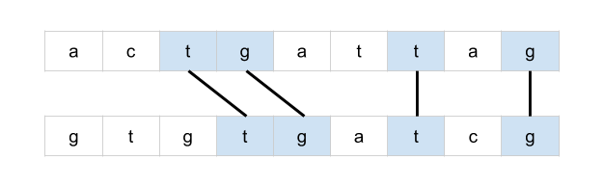

Drawing lines between corresponding letters is a great way of visualizing the problem and is potentially a valuable technique to use on a whiteboard during an interview. Observe that if lines cross over each other, then they do not represent a common subsequence.

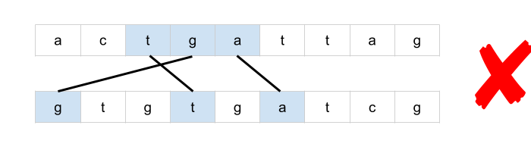

This is because lines that cross over are representing letters that have been rearranged.

We will use and refer to "lines" between the words extensively throughout this article.

**Brute-force**

The most obvious approach would be to iterate through each subsequence of the first string and check whether or not it is also a subsequence of the second string.

This, however, will require exponential time to run. The number of subsequences in a string is up to 2^L2*L*, where L*L* is the length of the string. This is because, for each character, we have two choices; it can either be in the subsequence or not in it. Duplicates characters reduce the number of unique subsequences a bit, although in the general case, it's still exponential.

This would be a brute-force approach.

**Greedy**

By this point, it's hopefully clear that we're dealing with an optimization problem. We need to generate a common subsequence that has the maximum possible number of letters. Using our analogy of drawing lines between the words, we could also phrase it as maximizing the number of non-crossing lines.

There are a couple of strategies we use to design a tractable (non-exponential) algorithm for an optimization problem.

1. Identifying a greedy algorithm
2. Dynamic programming

There is no guarantee that either is possible. Additionally, greedy algorithms are strictly less common than dynamic programming algorithms and are often more difficult to identify. However, if a greedy algorithm exists, then it will almost always be better than a dynamic programming one. You should, therefore, at least give some thought to the potential existence of a greedy algorithm before jumping straight into dynamic programming.

The best way of doing this is by drawing an example and playing around with it. One idea could be to iterate through the letters in the first word, checking whether or not it is possible to draw a line from it to the second word (without crossing lines). If it is, then draw the left-most line possible.

For example, here's what we would do with the first letter of our example from earlier.

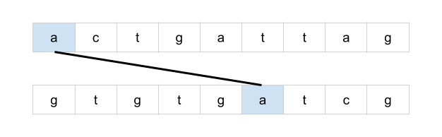

And then, the second letter.

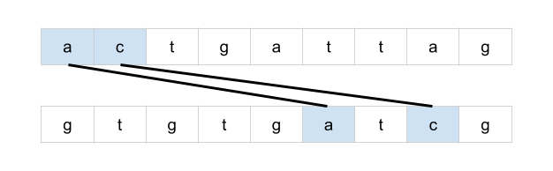

And finally, the third letter.

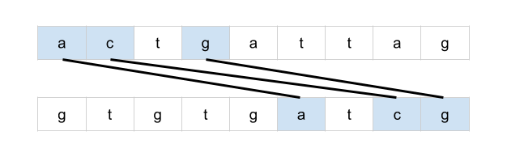

This solution, however, isn't optimal. Here is a better solution.

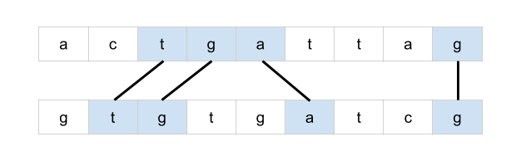

What if we were to do the same, but instead going from the second word to the first word? Perhaps one way or the other will always be optimal?

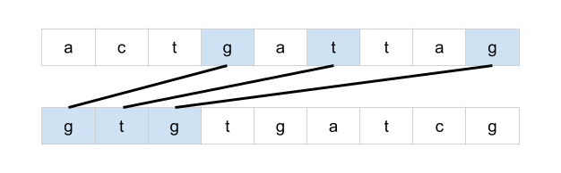

Unfortunately, this hasn't worked either. This solution is still worse than a better one we know about.

Perhaps, instead, we could draw all possible lines. Could there be a way of eliminating some of the lines that cross over?

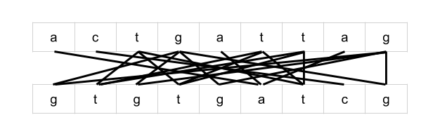

Uhoh, we now have what looks like an even more complicated problem than the one we began with. With some lines crossing over many other lines, where would you even begin?

**Applying Dynamic Programming to a Problem**

While it's very difficult to be certain that there is no greedy algorithm for your interview problem, over time you'll build up an intuition about when to give up. You also don't want to risk spending so long trying to find a greedy algorithm that you run out of time to write a dynamic programming one (and it's also best to make sure you write a working solution!).

Besides, sometimes the process used to develop a dynamic programming solution can lead to a greedy one. So, you might end up being able to further optimize your dynamic programming solution anyway.

Recall that there are two different techniques we can use to implement a dynamic programming solution; memoization and tabulation.

* **Memoization** is where we add caching to a function (that has no side effects). In dynamic programming, it is typically used on **recursive** functions for a **top-down** solution that starts with the initial problem and then recursively calls itself to solve smaller problems.
* **Tabulation** uses a table to keep track of subproblem results and works in a **bottom-up** manner: solving the smallest subproblems before the large ones, in an **iterative** manner. Often, people use the words "tabulation" and "dynamic programming" interchangeably.

For most people, it's easiest to start by coming up with a recursive brute-force solution and then adding memoization to it. After that, they then figure out how to convert it into an (often more desired) bottom-up tabulated algorithm.

#### **Approach 1: Memoization**

**Intuition**

The first step is to find a way to recursively break the original problem down into subproblems. We want to find subproblems such that we can create an optimal solution from the results of those subproblems.

Earlier, we were drawing lines between identical letters.



Consider the greedy algorithm we tried earlier where we took the first possible line. Instead of assuming that the line is part of the optimal solution, we could consider both cases: the line ***is*** part of the optimal solution or the line ***is not*** part of the optimal solution.

If the line ***is*** part of the optimal solution, then we know that the rest of the lines must be in the substrings that follow the line. As such, we should find the solution for the substrings, and add 1 onto the result (for the new line) to get the optimal solution.

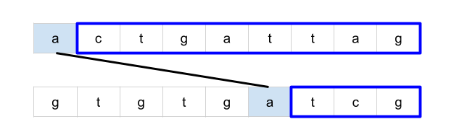

However, if the line ***is not*** part of the optimal solution, then we know that the letter in the first string is not included (as this would have been the best possible line for that letter). So, instead, we remove the first letter of the first string and treat the remainder as the subproblem. Its solution will be the optimal solution.

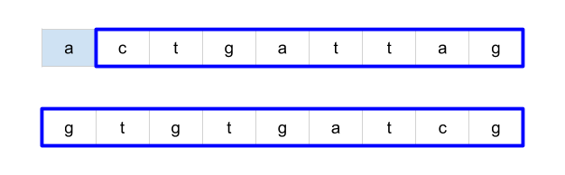

But remember, we don't know which of these two cases is true. As such, we need to compute the answer for **both** cases. The highest one will be the optimal solution and should be returned as the answer for this problem.

Note that if either the first string or the second string is of length 0, we don't need to break it into subproblems and can just return 0. This acts as the base case for the recursion.

But how many total subproblems will we need to solve? Well, because we always take a character off one, or both, of the strings each time, there are M \cdot N*M*⋅*N* possible subproblems (where M*M* is the length of the first string, and N*N* the length of the second string). Another way of seeing this is that subproblems are represented as suffixes of the original strings. A string of length K*K* has K*K* unique suffixes. Therefore, the first string has M*M* suffixes, and the second string has N*N* suffixes. There are, therefore, M \cdot N*M*⋅*N* possible pairs of suffixes.

Some subproblems may be visited multiple times, for example LCS("aac", "adf") has the two subproblems LCS("ac", "df") and LCS("ac", "adf"). Both of these share a common subproblem of LCS("c", "df"). As such, as we should memoize the results of LCS calls so that the answers of previously computed subproblems can immediately be returned without the need for re-computation.

**Algorithm**

From what we've explored in the intuition section, we can create a top-down recursive algorithm that looks like this in pseudocode:

define function LCS(text1, text2):

# If either string is empty there, can be no common subsequence.

if length of text1 or text2 is 0:

return 0

letter1 = the first letter in text1

firstOccurence = first position of letter1 in text2

# The case where the line *is not* part of the optimal solution

case1 = LCS(text1.substring(1), text2)

# The case where the line *is* part of the optimal solution

case2 = 1 + LCS(text1.substring(1), text2.substring(firstOccurence + 1))

return maximum of case1 and case2

You might notice from the pseudocode that there's one case we haven't handled: if letter1 isn't part of text2, then we can't solve the first subproblem. However, in this case, we can simply ignore the first subproblem as the line doesn't exist. This leaves us with:

define function LCS(text1, text2):

# If either string is empty there can be no common subsequence

if length of text1 or text2 is 0:

return 0

letter1 = the first letter in text1

# The case where the line *is not* part of the optimal solution

case1 = LCS(text1.substring(1), text2)

case2 = 0

if letter1 is in text2:

firstOccurence = first position of letter1 in text2

# The case where the line *is* part of the optimal solution

case2 = 1 + LCS(text1.substring(1), text2.substring(firstOccurence + 1))

return maximum of case1 and case2

Remember, we need to make sure that the results of this method are memoized. In **Python**, we can use lru_cache. In **Java**, we need to make our own data structure. A 2D Array is the best option (see the code for the details of how this works).

|  |
| --- |
| class Solution {    private int[][] memo;  private String text1;  private String text2;    public int longestCommonSubsequence(String text1, String text2) {  // Make the memo big enough to hold the cases where the pointers  // go over the edges of the strings.  this.memo = new int[text1.length() + 1][text2.length() + 1];  // We need to initialise the memo array to -1's so that we know  // whether or not a value has been filled in. Keep the base cases  // as 0's to simplify the later code a bit.  for (int i = 0; i < text1.length(); i++) {  for (int j = 0; j < text2.length(); j++) {  this.memo[i][j] = -1;  }  }  this.text1 = text1;  this.text2 = text2;  return memoSolve(0, 0);  }  private int memoSolve(int p1, int p2) {  // Check whether or not we've already solved this subproblem.  // This also covers the base cases where p1 == text1.length  // or p2 == text2.length.  if (memo[p1][p2] != -1) {  return memo[p1][p2];  }  // Option 1: we don't include text1[p1] in the solution.  int option1 = memoSolve(p1 + 1, p2);  // Option 2: We include text1[p1] in the solution, as long as  // a match for it in text2 at or after p2 exists.  int firstOccurence = text2.indexOf(text1.charAt(p1), p2);  int option2 = 0;  if (firstOccurence != -1) {  option2 = 1 + memoSolve(p1 + 1, firstOccurence + 1);  }  // Add the best answer to the memo before returning it.  memo[p1][p2] = Math.max(option1, option2);  return memo[p1][p2];  }  } |

**Complexity Analysis**

* Time complexity : O(M \cdot N^2)*O*(*M*⋅*N*2).

We analyze a memoized-recursive function by looking at how many unique subproblems it will solve, and then what the cost of solving each subproblem is.

The input parameters to the recursive function are a pair of integers; representing a position in each string. There are M*M* possible positions for the first string, and N*N* for the second string. Therefore, this gives us M \cdot N*M*⋅*N* possible pairs of integers, and is the number of subproblems to be solved.

Solving each subproblem requires, in the worst case, an O(N)*O*(*N*) operation; searching for a character in a string of length N*N*. This gives us a total of (M \cdot N^2)(*M*⋅*N*2).

* Space complexity : O(M \cdot N)*O*(*M*⋅*N*).

We need to store the answer for each of the M \cdot N*M*⋅*N* subproblems. Each subproblem takes O(1)*O*(1) space to store. This gives us a total of O(M \cdot N)*O*(*M*⋅*N*).

It is important to note that the time complexity given here is an upper bound. In practice, many of the subproblems are unreachable, and therefore not solved.

For example, if the first letter of the first string is not in the second string, then only one subproblem that has the entire first word is even considered (as opposed to the N*N* possible subproblems that have it). This is because when we search for the letter, we skip indices until we find the letter, skipping over a subproblem at each iteration. In the case of the letter not being present, no further subproblems are even solved with that particular first string.

#### **Approach 2: Improved Memoization**

**Intuition**

There is an alternative way of expressing the solution recursively. The code is simpler, and will also translate a lot more easily into a bottom-up dynamic programming approach.

The subproblems are of the same structure as before; represented as two indexes. Also, like before, we're going to be considering multiple possible decisions and then going with the one that has the highest answer. The difference is that the way we break a problem into subproblems is a bit different. For example, here is how our example from before breaks into subproblems.

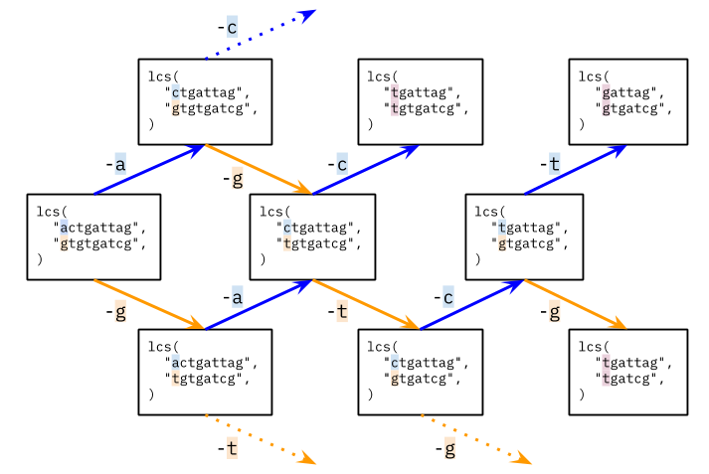

If the first character of each string is **not** the same, then either one or both of those characters will not be used in the final result (i.e. not have a line drawn to or from it). Therefore, the length of the longest common subsequence is max(LCS(p1 + 1, p2), LCS(p1, p2 + 1)).

Now, what about subproblems such as LCS("tgattag", "tgtgatcg")? The first letter of each string is the same, and so we could draw a line between them. Should we? Well, there is no reason not to draw a line between the first characters when they're the same. This is because it won't block any later (optimal) decisions. No letters other than those used for the line are removed from consideration by it. Therefore, we don't need to make a decision in this case.

When the first character of each string is the same, the length of the longest common subsequence is 1 + LCS(p1 + 1, p2 + 1). In other words, we draw a line a line between the first two characters, adding 1 to the length to represent that line, and then solving the resulting subproblem (that has the first character removed from each string).

Here is a few more of the subproblems for the above example.

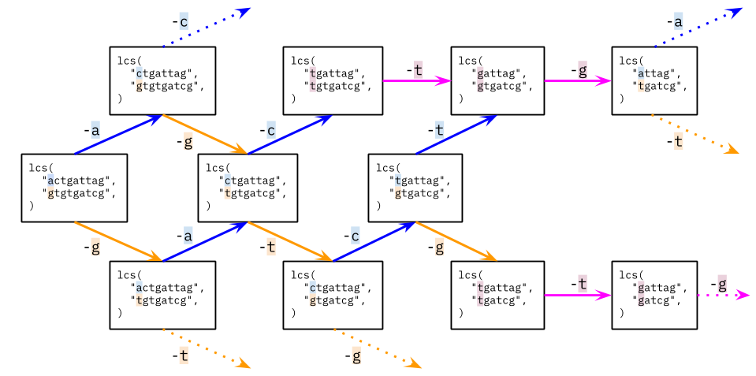

Like before, we still have overlapping subproblems, i.e. subproblems that appear on more than one branch. Therefore, we should still be using a memoization table, just like before.

**Algorithm**

|  |
| --- |
| class Solution {    private int[][] memo;  private String text1;  private String text2;    public int longestCommonSubsequence(String text1, String text2) {  // Make the memo big enough to hold the cases where the pointers  // go over the edges of the strings.  this.memo = new int[text1.length() + 1][text2.length() + 1];  // We need to initialise the memo array to -1's so that we know  // whether or not a value has been filled in. Keep the base cases  // as 0's to simplify the later code a bit.  for (int i = 0; i < text1.length(); i++) {  for (int j = 0; j < text2.length(); j++) {  this.memo[i][j] = -1;  }  }  this.text1 = text1;  this.text2 = text2;  return memoSolve(0, 0);  }  private int memoSolve(int p1, int p2) {  // Check whether or not we've already solved this subproblem.  // This also covers the base cases where p1 == text1.length  // or p2 == text2.length.  if (memo[p1][p2] != -1) {  return memo[p1][p2];  }  // Recursive cases.  int answer = 0;  if (text1.charAt(p1) == text2.charAt(p2)) {  answer = 1 + memoSolve(p1 + 1, p2 + 1);  } else {  answer = Math.max(memoSolve(p1, p2 + 1), memoSolve(p1 + 1, p2));  }    // Add the best answer to the memo before returning it.  memo[p1][p2] = answer;  return memo[p1][p2];  }  } |

**Complexity Analysis**

* Time complexity : O(M \cdot N)*O*(*M*⋅*N*).

This time, solving each subproblem has a cost of O(1)*O*(1). Again, there are M \cdot N*M*⋅*N* subproblems, and so we get a total time complexity of O(M \cdot N)*O*(*M*⋅*N*).

* Space complexity : O(M \cdot N)*O*(*M*⋅*N*).

We need to store the answer for each of the M \cdot N*M*⋅*N* subproblems.

#### **Approach 3: Dynamic Programming**

**Intuition**

In many programming languages, iteration is faster than recursion. Therefore, we often want to convert a top-down memoization approach into a bottom-up dynamic programming one (some people go directly to bottom-up, but most people find it easier to come up with a recursive top-down approach first and then convert it; either way is fine).

Observe that the subproblems have a natural "size" ordering; the largest subproblem is the one we start with, and the smallest subproblems are the ones with just one letter left in each word. The answer for each subproblem depends on the answers to some of the smaller subproblems.

Remembering too that each subproblem is represented as a pair of indexes, and that there are text1.length() * text2.length() such possible subproblems, we can iterate through the subproblems, starting from the smallest ones, and storing the answer for each. When we get to the larger subproblems, the smaller ones that they depend on will already have been solved. The best way to do this is to use a 2D array.

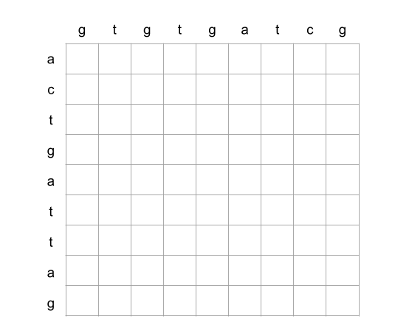

Each cell represents one subproblem. For example, the below cell represents the subproblem lcs("attag", "gtgatcg").

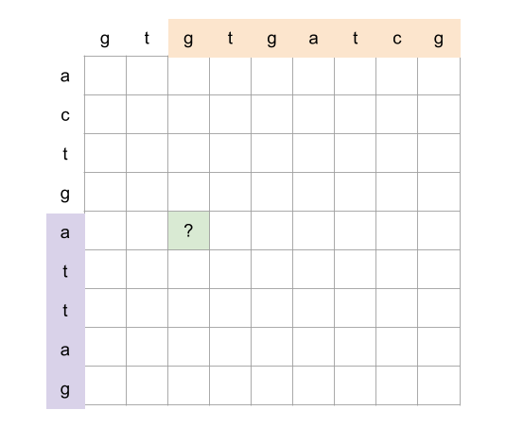

Remembering back to Approach 2, there were two cases.

1. The first letter of each string is the same.
2. The first letter of each string is different.

For the first case, we solve the subproblem that removes the first letter from each, and add 1. In the grid, this subproblem is always the diagonal immediately down and right.

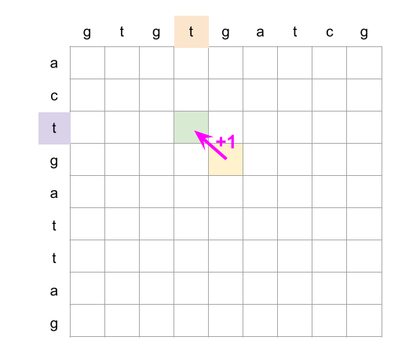

For the second case, we consider the subproblem that removes the first letter off the first word, and then the subproblem that removes the first letter off the second word. In the grid, these are subproblems immediately right and below.

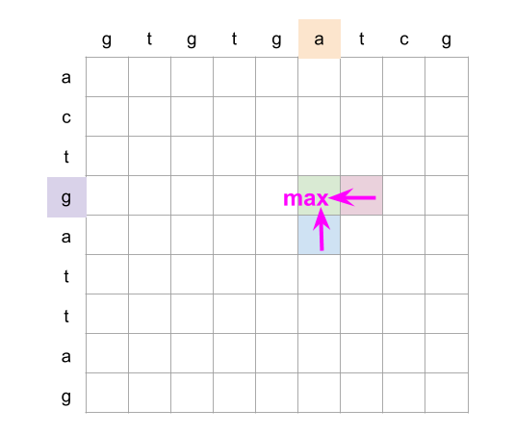

Putting this all together, we iterate over each column in reverse, starting from the last column (we could also do rows, the final result will be the same). For a cell (row, col), we look at whether or not text1.charAt(row) == text2.charAt(col) is true. if it is, then we set grid[row][col] = 1 + grid[row + 1][col + 1]. Otherwise, we set grid[row][col] = max(grid[row + 1][col], grid[row][col + 1]).

For ease of implementation, we add an extra row of zeroes at the bottom, and an extra column of zeroes to the right.

Here is an animation showing this algorithm.



|  |
| --- |
| class Solution {    public int longestCommonSubsequence(String text1, String text2) {    // Make a grid of 0's with text2.length() + 1 columns  // and text1.length() + 1 rows.  int[][] dpGrid = new int[text1.length() + 1][text2.length() + 1];    // Iterate up each column, starting from the last one.  for (int col = text2.length() - 1; col >= 0; col--) {  for (int row = text1.length() - 1; row >= 0; row--) {  // If the corresponding characters for this cell are the same...  if (text1.charAt(row) == text2.charAt(col)) {  dpGrid[row][col] = 1 + dpGrid[row + 1][col + 1];  // Otherwise they must be different...  } else {  dpGrid[row][col] = Math.max(dpGrid[row + 1][col], dpGrid[row][col + 1]);  }  }  }    // The original problem's answer is in dp_grid[0][0]. Return it.  return dpGrid[0][0];  }  } |

**Complexity Analysis**

* Time complexity : O(M \cdot N)*O*(*M*⋅*N*).

We're solving M \cdot N*M*⋅*N* subproblems. Solving each subproblem is an O(1)*O*(1) operation.

* Space complexity : O(M \cdot N)*O*(*M*⋅*N*).

We'e allocating a 2D array of size M \cdot N*M*⋅*N* to save the answers to subproblems.

#### **Approach 4: Dynamic Programming with Space Optimization**

**Intuition**

You might have noticed in the Approach 3 animation that we only ever looked at the current column and the previous column. After that, previously computed columns are no longer needed (if you didn't notice, go back and look at the animation).

We can save a lot of space by instead of keeping track of an entire 2D array, only keeping track of the last two columns.

This reduces the space complexity to be proportional to the length of the word going down. We should make sure this is the shortest of the two words.

**Algorithm**

|  |
| --- |
| class Solution {    public int longestCommonSubsequence(String text1, String text2) {    // If text1 doesn't reference the shortest string, swap them.  if (text2.length() < text1.length()) {  String temp = text1;  text1 = text2;  text2 = temp;  }    // The previous column starts with all 0's and like before is 1  // more than the length of the first word.  int[] previous = new int[text1.length() + 1];    // Iterate through each column, starting from the last one.  for (int col = text2.length() - 1; col >= 0; col--) {  // Create a new array to represent the current column.  int[] current = new int[text1.length() + 1];  for (int row = text1.length() - 1; row >= 0; row--) {  if (text1.charAt(row) == text2.charAt(col)) {  current[row] = 1 + previous[row + 1];  } else {  current[row] = Math.max(previous[row], current[row + 1]);  }  }  // The current column becomes the previous one.  previous = current;  }    // The original problem's answer is in previous[0]. Return it.  return previous[0];  }  } |

We can still do better! Thanks [@heinzerm](https://leetcode.com/heinzerm/) for bringing this up in the comments :)

One slight inefficiency in the above code is that a new current array is created on each loop cycle. While this doesn't affect the space complexity—as we assume garbage collection happens immediately for the purposes of space complexity analysis—it does improve the actual time and space usage by a constant amount.

A couple of people have suggested that we could create current in the same place we create previous. Then each time, the current array will be reused. This, they argue, should work because we never modify the 0 at the end (the padding), and then, other than that 0, we're only ever reading from indexes that we've already written to on that outer-loop iteration. This logic is entirely correct.

However, it will break for a different reason. The line previous = current makes both previous and current reference ***the same*** list. This happens at the end of the first loop cycle. So after that point, the algorithm is no longer functioning as intended.

There is another solution, though: notice that when we do previous = current, we are removing the reference to the previous array. At this point, it would normally be garbage collected. Instead, though, we could use that array as our current array for the next iteration! This way, we're not making both variables reference the same array, and we're reusing a no longer array instead of creating a new one. Correctness is guaranteed, as explained above, we're only ever reading the 0 at the end or values we've already written to in that outer-loop iteration.

Here is the slightly modified code for your reference.

|  |
| --- |
| class Solution {    public int longestCommonSubsequence(String text1, String text2) {    // If text1 doesn't reference the shortest string, swap them.  if (text2.length() < text1.length()) {  String temp = text1;  text1 = text2;  text2 = temp;  }    // The previous and current column starts with all 0's and like  // before is 1 more than the length of the first word.  int[] previous = new int[text1.length() + 1];  int[] current = new int[text1.length() + 1];    // Iterate through each column, starting from the last one.  for (int col = text2.length() - 1; col >= 0; col--) {  for (int row = text1.length() - 1; row >= 0; row--) {  if (text1.charAt(row) == text2.charAt(col)) {  current[row] = 1 + previous[row + 1];  } else {  current[row] = Math.max(previous[row], current[row + 1]);  }  }  // The current column becomes the previous one, and vice versa.  int[] temp = previous;  previous = current;  current = temp;  }    // The original problem's answer is in previous[0]. Return it.  return previous[0];  }  } |

**Complexity Analysis**

Let M*M* be the length of the first word, and N*N* be the length of the second word.

* Time complexity : O(M \cdot N)*O*(*M*⋅*N*).

Like before, we're solving M \cdot N*M*⋅*N* subproblems, and each is an O(1)*O*(1) operation to solve.

* Space complexity : O(\min(M, N))*O*(min(*M*,*N*)).

We've reduced the auxilary space required so that we only use two 1D arrays at a time; each the length of the shortest input word. Seeing as the 22 is a constant, we drop it, leaving us with the minimum length out of the two words.

**First Unique Number**

You have a queue of integers, you need to retrieve the first unique integer in the queue.

Implement the FirstUnique class:

* FirstUnique(int[] nums) Initializes the object with the numbers in the queue.
* int showFirstUnique() returns the value of **the first unique** integer of the queue, and returns **-1** if there is no such integer.
* void add(int value) insert value to the queue.

**Example 1:**

**Input:**

["FirstUnique","showFirstUnique","add","showFirstUnique","add","showFirstUnique","add","showFirstUnique"]

[[[2,3,5]],[],[5],[],[2],[],[3],[]]

**Output:**

[null,2,null,2,null,3,null,-1]

**Explanation:**

FirstUnique firstUnique = new FirstUnique([2,3,5]);

firstUnique.showFirstUnique(); // return 2

firstUnique.add(5); // the queue is now [2,3,5,5]

firstUnique.showFirstUnique(); // return 2

firstUnique.add(2);            // the queue is now [2,3,5,5,2]

firstUnique.showFirstUnique(); // return 3

firstUnique.add(3);            // the queue is now [2,3,5,5,2,3]

firstUnique.showFirstUnique(); // return -1

**Example 2:**

**Input:**

["FirstUnique","showFirstUnique","add","add","add","add","add","showFirstUnique"]

[[[7,7,7,7,7,7]],[],[7],[3],[3],[7],[17],[]]

**Output:**

[null,-1,null,null,null,null,null,17]

**Explanation:**

FirstUnique firstUnique = new FirstUnique([7,7,7,7,7,7]);

firstUnique.showFirstUnique(); // return -1

firstUnique.add(7); // the queue is now [7,7,7,7,7,7,7]

firstUnique.add(3);            // the queue is now [7,7,7,7,7,7,7,3]

firstUnique.add(3);            // the queue is now [7,7,7,7,7,7,7,3,3]

firstUnique.add(7);            // the queue is now [7,7,7,7,7,7,7,3,3,7]

firstUnique.add(17);           // the queue is now [7,7,7,7,7,7,7,3,3,7,17]

firstUnique.showFirstUnique(); // return 17

**Example 3:**

**Input:**

["FirstUnique","showFirstUnique","add","showFirstUnique"]

[[[809]],[],[809],[]]

**Output:**

[null,809,null,-1]

**Explanation:**

FirstUnique firstUnique = new FirstUnique([809]);

firstUnique.showFirstUnique(); // return 809

firstUnique.add(809); // the queue is now [809,809]

firstUnique.showFirstUnique(); // return -1

**Constraints:**

* 1 <= nums.length <= 10^5
* 1 <= nums[i] <= 10^8
* 1 <= value <= 10^8
* At most 50000 calls will be made to showFirstUnique and add.

 Hide Hint #1

Use doubly Linked list with hashmap of pointers to linked list nodes. add unique number to the linked list. When add is called check if the added number is unique then it have to be added to the linked list and if it is repeated remove it from the linked list if exists. When showFirstUnique is called retrieve the head of the linked list.

   Hide Hint #2

Use queue and check that first element of the queue is always unique.

   Hide Hint #3

Use set or heap to make running time of each function O(logn).

## Solution

#### **Approach 1: Brute Force**

**Intuition**

The simplest solution for this problem is to create a queue as normal, and then search through it to find the first unique number.

We do this by looping through the items in the queue (starting from the oldest). For each item, we loop through the queue again, counting how many times it appears. If it only appears once, we stop and return it. If there are no items that appear only once, then we return -1.

**Algorithm**

We don't need to implement counting ourselves; we can use Collections.frequency(...) in Java, and .count(...) in Python.

|  |
| --- |
| class FirstUnique {  private Queue<Integer> queue = new ArrayDeque<>();    public FirstUnique(int[] nums) {  for (int num : nums) {  queue.add(num);  }  }    public int showFirstUnique() {  for (int num : queue) {  int count = Collections.frequency(queue, num);  if (count == 1) {  return num;  }  }  return -1;  }    public void add(int value) {  queue.add(value);  }  } |

**Complexity Analysis**

Let K*K* be the length of the initial array passed into the constructor. Let N*N* be the total number of items added onto the queue so far (including those from the constructor).

* Time complexity :
  + **constructor**: O(K)*O*(*K*).

We create a new copy of the passed in numbers; this has a cost of O(K)*O*(*K*) time to create.

* + **add()**: O(1)*O*(1).

We perform a single append to a queue; this has a cost of O(1)*O*(1).

* + **showFirstUnique()**: O(N^2)*O*(*N*2).

Counting how many times a given item appears in the queue has a cost of O(N)*O*(*N*). This is true even for the library functions we're using.

In the worst case, we search through the entire queue without finding a unique number. At a cost of O(N)*O*(*N*) each time, this gives us a cost of O(N^2)*O*(*N*2).

* Space complexity : O(N)*O*(*N*).

The memory used is simply the total number of items currently in the queue.

#### **Approach 2: Queue and HashMap of Unique-Status**

**Intuition**

When given a data-structure-design question like this one, a good strategy is to start simple and identify where the inefficiencies are.

In Approach 1, we performed numerous count operations; each call to showFirstUnique() performed, in the worst case, N*N* count operations. At a cost of O(N)*O*(*N*) per count, this was expensive! These count-ups are also repetitive, and so should be our focus for optimization.

When deciding whether or not to return a particular number, all we need to know is whether or not that number is unique. In other words, we only want to know whether it has occurred "once", or "more than once". Seeing as numbers cannot be removed from the FirstUnique data structure, we know that once a particular number is added for the second time, that number will never again be unique.

So, instead of counting how many times a number occurred in the queue, we could instead keep a HashMap of numbers to booleans, where for each number that has been added, we're storing the answer to the question is this number unique?. We'll call it isUnique. Then, when FirstUnique.add(number) is called, one of three cases will apply:

1. This particular number has never been seen before now. Add it to isUnique with a value of true. Also, add it to the queue.
2. This particular number has already been seen by isUnique, with a value of true. This means that the number was previously unique (and is currently in the queue), but with this new addition, it no longer is. Update its value to false. Do not add it to the queue.
3. This particular number has already been seen by isUnique, with a value of false. This means that it has already been seen twice before. We don't need to do anything, and shouldn't add it to the queue.

Then, instead of needing to perform "count" operations, the showFirstUnique() can simply look in isUnique for the information it needs.

Here is an animation showing how this works so far.



This is a good start. However, you might have noticed another inefficiency while watching the animation: the 7 at the front needs to be stepped passed on every call to showFirstUnique(). As soon as the second 7 was added, though, this 7 was no longer unique, and so would never be the answer to a call to showFirstUnique() again (remember, this queue has no deletion operation). Therefore, there is no reason to leave it in the queue—we should remove it so that we don't keep looking at it.

But, where should we actually do these removals from the queue? In showFirstUnique(), or in add()?

* If we do a removal in the add() method, we'll need to do an O(N)*O*(*N*) search of the queue to find the number, and then potentially another to remove it from the queue, (if you're chosen programming language even supports deletions from the middle of a queue!).
* If we do the removal in the showFirstUnique() method, we might sometimes need to do lots of removals before we find a unique number to return. However, it will be faster across all calls to the data structure, because we didn't need to do a search to find the non-unique number like we would have with add(). We'll talk more about this in the time complexity section.

So, our best option is to do the removals in the showFirstUnique() method.

We should leave the number's value as false in isUnique, though. Like we said above, a number can never "become" unique again.

Here is an animation showing the full algorithm.



|  |
| --- |
| class FirstUnique {  private Queue<Integer> queue = new ArrayDeque<>();  private Map<Integer, Boolean> isUnique = new HashMap<>();  public FirstUnique(int[] nums) {  for (int num : nums) {  // Notice that we're calling the "add" method of FirstUnique; not of the queue.  this.add(num);  }  }  public int showFirstUnique() {  // We need to start by "cleaning" the queue of any non-uniques at the start.  // Note that we know that if a value is in the queue, then it is also in  // isUnique, as the implementation of add() guarantees this.  while (!queue.isEmpty() && !isUnique.get(queue.peek())) {  queue.remove();  }  // Check if there is still a value left in the queue. There might be no uniques.  if (!queue.isEmpty()) {  return queue.peek(); // We don't want to actually *remove* the value.  }  return -1;  }  public void add(int value) {  // Case 1: We need to add the number to the queue and mark it as unique.  if (!isUnique.containsKey(value)) {  isUnique.put(value, true);  queue.add(value);  // Case 2 and 3: We need to mark the number as no longer unique.  } else {  isUnique.put(value, false);  }  }  } |

**Complexity Analysis**

Let K*K* be the length of the initial array passed into the constructor.

Let N*N* be the total number of items added onto the queue so far (including those from the constructor).

* Time complexity :
  + **constructor**: O(K)*O*(*K*).

For each of the K*K* numbers passed into the constructor, we're making a call to add(). As we will determine below, each call to add() has a cost of O(1)*O*(1). Therefore, for the K*K* numbers added in the constructor, we get a total cost of K \cdot O(1) = O(K)*K*⋅*O*(1)=*O*(*K*).

* + **add()**: O(1)*O*(1).

We check the status of the number in a HashMap, which is an O(1)*O*(1) operation. We also optionally modify its status in the HashMap, which, again, is an O(1)*O*(1) operation.

Depending on the status of the number, we add it to the queue, which is again, an O(1)*O*(1) operation.

Therefore, we get an O(1)*O*(1) time complexity for the add() method.

* + **showFirstUnique()**: O(1)*O*(1) (amortized).

For this implementation, the showFirstUnique() method needs to iterate down the queue until it finds a unique number. For each unique number it encounters along the way, it removes it. Removing an item from a queue has a cost of O(1)*O*(1). The total number of these removals we need to carry out is proportional to the number of calls to add(), because each add() corresponds to at most one removal that will ultimately have to happen. Then when we find a unique number, it is an O(1)*O*(1) operation to return it.

Because the number of O(1)*O*(1) removals is proportional to the number of calls to add(), we say that the time complexity amortizes across all calls to add() and showFirstUnique(), giving an overall time complexity of O(1)*O*(1) (amortized).

If you're not familiar with amortized time complexity, [check out the Wikipedia page](https://en.wikipedia.org/wiki/Amortized_analysis).

* Space complexity : O(N)*O*(*N*).

Each number is stored up to once in the queue, and up to once in the HashMap. Therefore, we get an overall space complexity of O(N)*O*(*N*).

#### **Approach 3: LinkedHashSet for Queue, and HashMap of Unique-Statuses**

**Intuition**

While an amortized time of O(1)*O*(1) will always be better than a non-amortized time of a higher complexity class, say, O(N)*O*(*N*), non-amortized O(1)*O*(1) would be even better. The downside of amortized time complexities is that while the average time per method call is "good", some calls might be really slow. Imagine if every one-millionth Google search took 1,000,000 ms, and all the others took 1 ms. The amortized time would be 2 ms, which, in theory, sounds great! However, the one-in-a-million person waiting 16 minutes for their search results won't be very happy with Google! (There would probably be less bad press if every search operation just took 5 ms...).

Is there a way we could remove the amortization from the data structure we designed in Approach 2?

For this to happen, we'd need to have each "removal" happen with its corresponding add(); not during some arbitrary showFirstUnique() call in the future. This is the only way we could avoid having lots of "waiting" removal operations. How does this work, though? Didn't we already decide it was too difficult?

* The trouble with doing the removal in the add() method was that it leads to a worst-case O(N)*O*(*N*) search of the queue, and potentially a worst-case O(N)*O*(*N*) removal from the middle of a queue—if it's even possible (Java doesn't allow removals from the middle of a queue).
* Making the actual remove an O(1)*O*(1) operation isn't too difficult; we simply need to use a LinkedList-based rather than Array-based queue implementation.
* Searching a LinkedList for a value is still O(N)*O*(*N*), though. The only data structures that supports search in O(1)*O*(1) time are hash-sets and hash-maps. But these don't maintain the input order; aren't we just going around in circles now?

There is another, not so well known, data structure we can use here: [LinkedHashSet](https://docs.oracle.com/en/java/javase/13/docs/api/java.base/java/util/LinkedHashSet.html). Note that in Python, we can use an [OrderedDict](https://docs.python.org/3.8/library/collections.html#collections.OrderedDict) to achieve the same functionality. If you have never heard of it, have a look at its specs before reading any further. Can you see how it solves our problem?

A LinkedHashSet is a HashSet-LinkedList hybrid. Like a HashSet, items can be found, updated, added, and removed in O(1)*O*(1) time. In addition, it puts links between the entries to keep track of the order they were added. Whenever an item is removed from the LinkedHashSet, the links are updated to point to the previous and next, just like they are in an ordinary LinkedList.

In essence, a LinkedHashSet is a type of queue that supports O(1)*O*(1) removals from the middle! This is exactly what we need to solve the problem. We can now do the removal in the add() method, and know that it is O(1)*O*(1).

**Algorithm**

|  |
| --- |
| class FirstUnique {    private Set<Integer> setQueue = new LinkedHashSet<>();  private Map<Integer, Boolean> isUnique = new HashMap<>();    public FirstUnique(int[] nums) {  for (int num : nums) {  this.add(num);  }  }    public int showFirstUnique() {  // If the queue contains values, we need to get the first one from it.  // We can do this by making an iterator, and getting its first item.  if (!setQueue.isEmpty()) {  return setQueue.iterator().next();  }  return -1;  }    public void add(int value) {  // Case 1: This value is not yet in the data structure.  // It should be ADDED.  if (!isUnique.containsKey(value)) {  isUnique.put(value, true);  setQueue.add(value);  // Case 2: This value has been seen once, so is now becoming  // non-unique. It should be REMOVED.  } else if (isUnique.get(value)) {  isUnique.put(value, false);  setQueue.remove(value);  }  }  } |

**Complexity Analysis**

Let K*K* be the length of the initial array passed into the constructor.

Let N*N* be the total number of items added onto the queue so far (including those from the constructor).

* Time complexity :
  + **constructor**: O(K)*O*(*K*).

For each of the K*K* numbers passed into the constructor, we're making a call to add(). As we will determine below, each call to add() has a cost of O(1)*O*(1). Therefore, for the K*K* numbers added in the constructor, we get a total cost of K \cdot O(1) = O(K)*K*⋅*O*(1)=*O*(*K*).

* + **add()**: O(1)*O*(1).

Like before, we're performing a series of O(1)*O*(1) operations when add() is called. Additionally, we're also removing the number from the queue if it had been unique, but now no longer is. Seeing as the queue is implemented as a LinkedHashSet, the cost of this removal is O(1)*O*(1).

Therefore, we get an O(1)*O*(1) time complexity for add().

* + **showFirstUnique()**: O(1)*O*(1).

This time around, the implementation for showFirstUnique() is straightforward. It simply checks whether or not the queue contains any items, and if it does, it returns the first one (without removing it). This has a cost of O(1)*O*(1).

* Space complexity : O(N)*O*(*N*).

Each number is stored up to once in the LinkedHashSet, and up to once in the HashMap. Therefore, we get an overall space complexity of O(N)*O*(*N*).

**Check If a String Is a Valid Sequence from Root to Leaves Path in a Binary Tree**

Given a binary tree where each path going from the root to any leaf form a **valid sequence**, check if a given string is a **valid sequence** in such binary tree.

We get the given string from the concatenation of an array of integers arr and the concatenation of all values of the nodes along a path results in a **sequence** in the given binary tree.

**Example 1:**

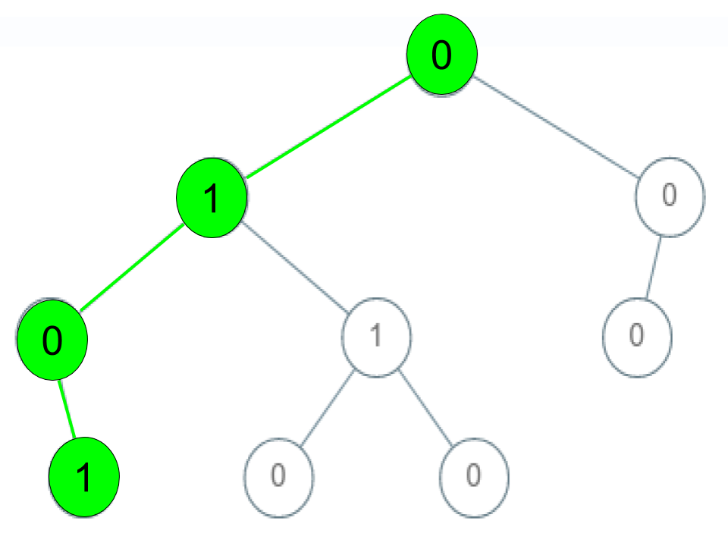

**Input:** root = [0,1,0,0,1,0,null,null,1,0,0], arr = [0,1,0,1]

**Output:** true

**Explanation:**

The path 0 -> 1 -> 0 -> 1 is a valid sequence (green color in the figure).

Other valid sequences are:

0 -> 1 -> 1 -> 0

0 -> 0 -> 0

**Example 2:**

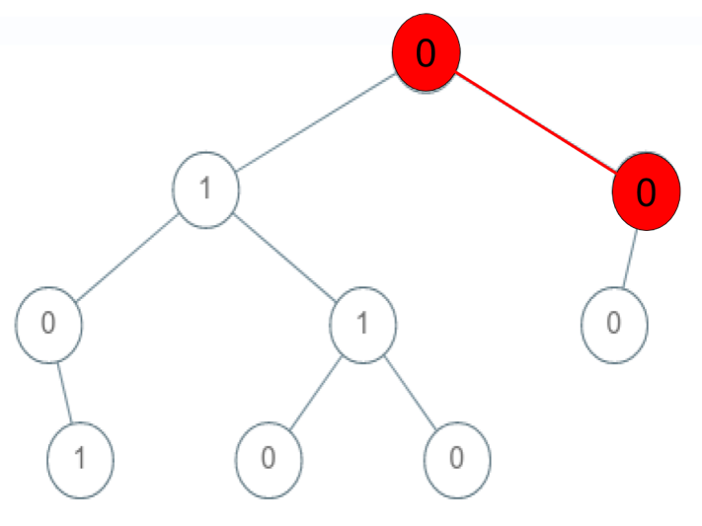

**Input:** root = [0,1,0,0,1,0,null,null,1,0,0], arr = [0,0,1]

**Output:** false

**Explanation:** The path 0 -> 0 -> 1 does not exist, therefore it is not even a sequence.

**Example 3:**

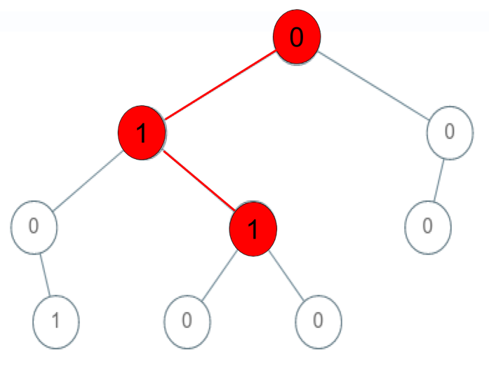

**Input:** root = [0,1,0,0,1,0,null,null,1,0,0], arr = [0,1,1]

**Output:** false

**Explanation:** The path 0 -> 1 -> 1 is a sequence, but it is not a valid sequence.

**Constraints:**

* 1 <= arr.length <= 5000
* 0 <= arr[i] <= 9
* Each node's value is between [0 - 9].

Hide Hint #1

Depth-first search (DFS) with the parameters: current node in the binary tree and current position in the array of integers.

   Hide Hint #2

When reaching at final position check if it is a leaf node.